6 Easy Ways to Stay Healthy

Not only is flu season just around the corner, but there have been cases of whooping cough and chickenpox in the county. Below are six easy things you
can do to keep yourself and the community healthy.

From the CDCs “Take 3 Actions to Fight the Flu” at http://www.cdc.gov/flu/protect/preventing.htm
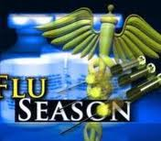 | TIP 1  Cover your nose and mouth with a tissue when you cough or sneeze. Throw the tissue in the trash after you use it. | 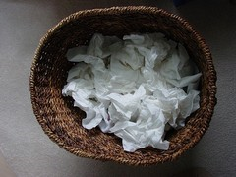
TIP 2  Sneeze into the inside of your  elbow – NOT into your hands.  Also avoid touching your eyes, nose and mouth; germs are easily spread this way. |  | TIP 3  Wash your hands often with soap and water. If soap is not available, use an alcohol-based  hand rub.
 | TIP 4  Try to avoid contact with people who are sick to reduce your chances of becoming ill. | 
TIP 5  If you are sick, limit contact  with others as much as possible to keep from  infecting them. |  | TIP 6  Protect yourself with vaccinations. The flu vaccine is available at UHS, as are other CDC recommended vaccines such as: Tdap (tetanus, diphtheria, and pertussis), Meningococcal (meningitis), and Varicella (chickenpox).




10/12/10 rb/sb

