Using a Food Thermometer

There is only one way to guarantee that your food is fully cooked and that is by temperature. Other methods can get you close but only temperature ensures that all the harmful bacteria that may be on your food have been killed.
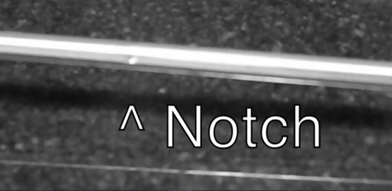
- Aim for the center of your food, or right along the bone when inserting your thermometer. These areas take the longest to cook and getting the temperature from these spots guarantees that your food is cooked all the way through.
- Insert the thermometer up to the notch. Most thermometers will have a notch on the stem. This notch needs to be completely inside of the food to get an accurate temperature, otherwise it may read as a higher temperature than what it actually is.

Safe Temeratures of Different Foods
Chicken | 165^{O} F
Pork | 160 ^{O} F
Beef | 145 ^{O} F
Ground Meats | 160 ^{O} F
Leftovers | 165 ^{O} F
Casseroles | 165 ^{O} F

