PERSONNEL TRAINING

GUIDANCE

Animal Care and Use training and documentation is required by OLAW (Health Research Extension Act and PHS Policy), AAALAC (Guide p.15), and the USDA (AWA 2.32 b.) and is an important part of maintaining a well-functioning animal care and use environment. Training may be presented as a mixture of observation and hands-on activity; however, the IACUC does not prescribe any specific training methodology.

Being trained means that the individual is proficient in the procedure and can perform the procedure to the satisfaction of the Principal Investigator or designee, Facility Leadership, or Veterinary Staff.

The IACUC and/or Veterinary Staff may require specific training, observe, or participate in training activities for novel procedures or other activities.

All personnel working with animals must complete:
- CITI Working with the IACUC
- CITI species and procedure (aseptic surgery and D and E procedures) specific module(s)
- CITI Online Biosafety Module (if applicable)
- CITI Basic Laboratory Safety Course
- Occupational Health and Safety Training is to be completed by all personnel per IACUC Policy.
- General animal facility training/orientation
- Laboratory/Protocol specific procedures per an individual’s involvement

Training completed through the Occupational Health Program and CITI are automatically documented.

Lab and protocol specific training must be provided by, documented, and verified by appropriately qualified personnel. Training records must be made available to the IACUC upon request. Supplemental and specialized training and training support is available through the IACUC and Attending Veterinarian and can be coordinated by the Office of Research Compliance. Additionally, the IACUC regularly sponsors group training that addresses common or significant topics.

The resources below can be used to support documentation efforts.
- Training sheet (can be used as a paper version or saved in a One Drive folder).
- Online, Qualtrics based training tracking tool that you may edit to fit your lab needs. Instructions for loading the survey are provided below. Review the sample.
  - Contact researchcompliance@kent.edu for configuration assistance.

The steps below can be view in The steps below can be viewed in this video.

 | The PI should complete this process, so they can manage the data.
1. | Download the survey file; save it where you can easily find it. This file contains code that is easily uploaded to Qualtrics.
2. | Log in to Qualtrics: https://kent.qualtrics.com/
3. | Click “create a new project.”
4. | Click “survey,” then “get started”
 | 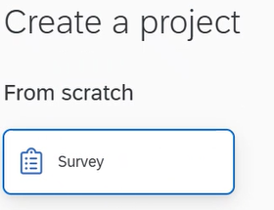
5. | Name your project, select “Import a QSF file.”
 | 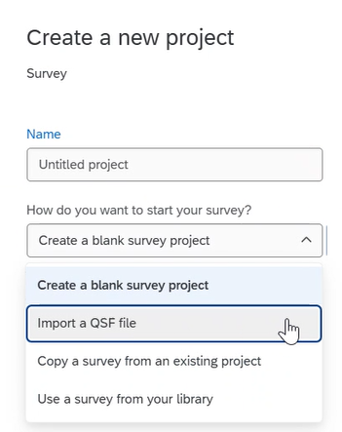
6. | Click “choose file” and select the downloaded document from step one; CLICK CREATE PROJECT and the survey will open.
 | 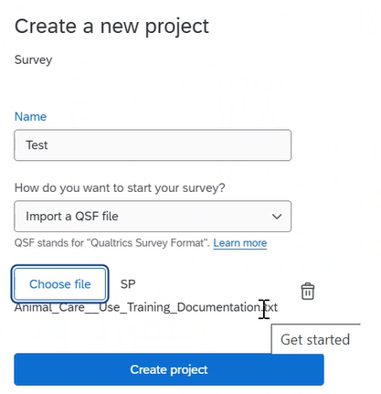
7. | To automatically CC the PI on all training, click Survey Options, Post-Survey, Edit Triggers, click the Trigger, add the PI email address, and click Save Triggers.
 | 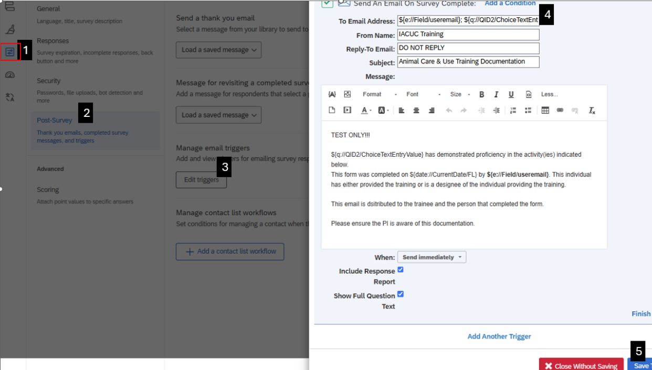
8. | Test the survey and edit as you see fit.
9. | Click PUBLISH.
 | 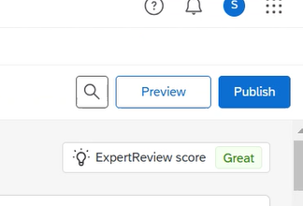
10. | Use a QR code to simplify access to the training tracking tool. Follow the steps to create a QR code.  - Open the survey.  - Click “Distributions.”  - Click “QR Code.”  - Download and print/share the QR code with lab members.
11. | The survey is ready to be distributed and used. DON’T FORGET TO DOUBLE CHECK THAT THE SURVEY IS PUBLISHED!
12. | The trainer and trainee will receive an email with the training record. The PI will also receive and email if they added their email address per step 7.
13. | Access training data. Log into Qualtrics and access the survey. CLICK Data & Analysis. View the data by exporting it or creating filters.  IMPORTANT: the data is only saved to the survey owner’s account, which is why we recommend the survey be provisioned under the PI’s Qualtrics account.
 | 