KENT STATE UNIVERSITY
COLLEGE OF EDUCATION, HEALTH AND HUMAN SERVICES

KSU TeachCS | 2026-2027 Cohort

Attention Teachers: Application for Free Education & Computer Science Endorsement
The State of Ohio recently awarded several institutions in the State with funding to prepare teachers to teach Computer Science. At Kent State University, funds will be used to provide 10 teachers with a tuition-free Computer Science Endorsement preparation program.
This program will not pay for the application to Kent State if you do not apply using these directions ($50). Read this document carefully. But if you are chosen for a scholarship, the entire program will be tuition-free. You will also receive free materials for preparing for the exam and up to (2) times taking the endorsement exam.
Please note that entrants in either program must have a valid Ohio teaching license.
- Your application must include a written statement that addresses your current and future plans for teaching computer science, particularly noting your interest in using this scholarship to obtain a license to teach computer science.
- Your application must also include two letters of recommendation; one of those must be from an administrator who is able to address why CS is important to the school/district and the role they see you playing in positively impacting CS in the school/district (i.e., teaching).

COMPUTER SCIENCE ENDORSEMENT PREPARATION PROGRAM (NON-DEGREE)

**MUST HOLD A VALID (UNEXPIRED) RESIDENT EDUCATOR (NOT “ALTERNATIVE”) OR PROFESSIONAL STATE OF OHIO TEACHING LICENSE AND A MASTER’S DEGREE IN EDUCATION OR ANOTHER APPROPRIATE FIELD. IF YOU DO NOT HOLD A MASTER’S DEGREE-IT IS RECOMMENDED YOU PURSUE THE ENDORSEMENT THROUGH THE MASTER OF EDUCATION IN EDUCATIONAL TECHNOLOGY WITH COMPUTER SCIENCE ENDORSEMENT PREPARATION CONCENTRATION. **
Admission Requirements
- Master’s degree in education or another appropriate field from an accredited institution
- Minimum 2.750 GPA on a 4.000 point scale (last degree)
- Evidence of valid Resident Educator (NOT Alternative) or Professional State of Ohio teaching license
- Official transcript(s): [Must submit all transcripts from colleges/universities in which a DEGREE (Associates, Bachelors, etc) was earned.. You may upload copies of OFFICIAL transcripts to speed up app process but if offered admission, you are required to submit OFFICIAL transcripts directly from all institutions. KSU transcripts can be accessed internally.]
- Goal statement
- Two letters of recommendation from academic and professional references (highly recommended you use the online recommendation system)

The graduate admission process is handled completely online. There is a $25 non-refundable application fee for the endorsement prep program. Your application will be processed GRADUATE ADMISSIONS:

Street Address: 800 E. Summit St., 161 Schwartz Center, Kent State University, Kent, OH 44242
Mailing Address (Transcripts): Graduate Admissions, P.O. Box 5190, Kent, OH 44242
Phone: 330-672-2444
Toll-Free: 1-800-988-KENT
Email (for questions/issues and Electronic Transcripts): gradapps@kent.edu

For questions regarding the KSU TeachCS 2026-2027 cohort program, please email pd@kent.edu.

APPLICATION INSTRUCTIONS
From the KENT STATE UNIVERSITY APPLICATION PORTAL: https://apply.kent.edu/apply/ , you will either log in or create a new account to start the online application process. You will “Start a New Application” as a “GRADUATE” student.
Under the “INITIAL QUESTIONS GRADUATE” tab-for which degree or credential are you pursuing, SELECT: Non-Degree Endorsement
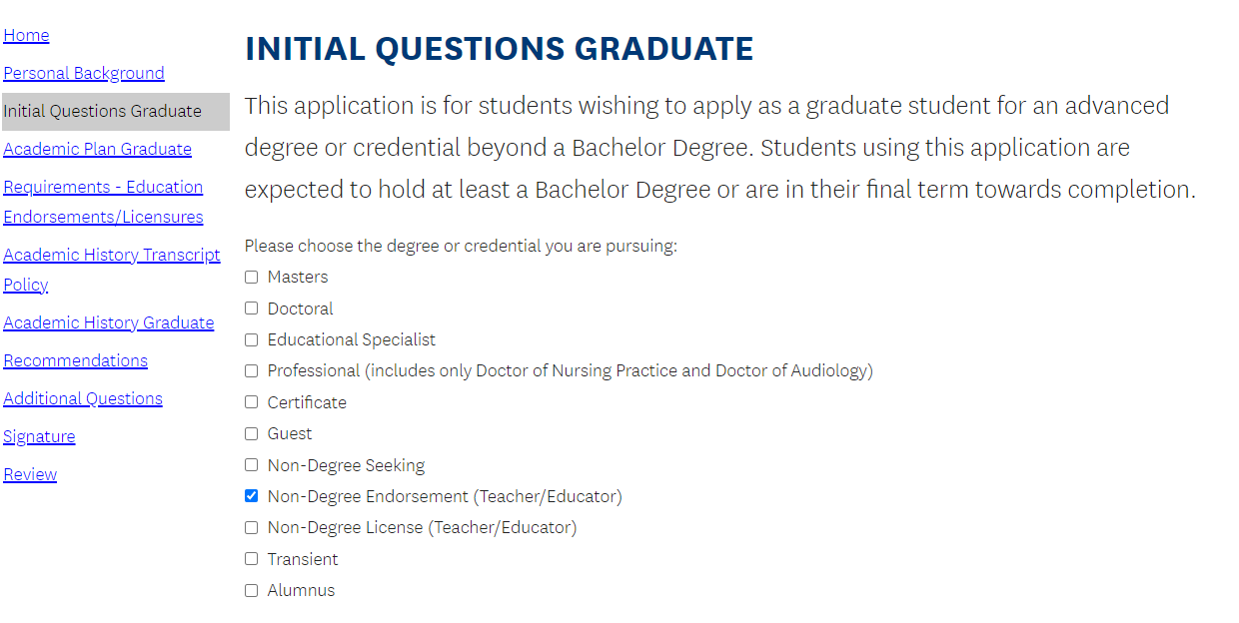

Under “ACADEMIC PLAN GRADUATE” tab, SELECT: Computer Science Endorsement Preparation-Non-Degree (under the College of Education, Health and Human Services Endorsement Preparation-Non-Degree)
Then SELECT: Fall 2025

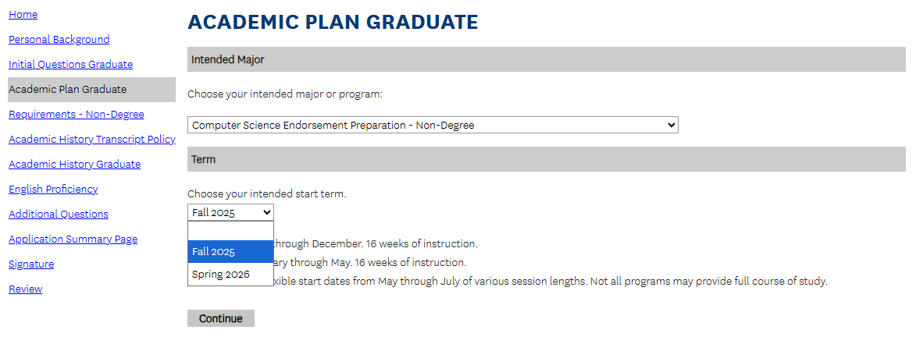

Under “REQUIREMENTS-EDUCATION ENDORSEMENTS/LICENSURES-Answer the questions accordingly: SELECT YES to having a current, valid Resident Educator (NOT Alternative) or Professional Ohio teaching license; TYPE your teaching licensure area (for example: Integrated Math 7-12); SELECT NO if you plan to pursue a degree simultaneously; SELECT NO for pursuing additional licenses simultaneously.
Under this tab- you will upload your Goal Statement (no specific format required) and upload a copy of your valid (unexpired) Resident Educator (Not Alternative) or Professional Ohio teaching license.
Goal Statement requirement information:
- Your application must include a written statement that addresses your current and future plans for teaching computer science, particularly noting your interest in using this scholarship to obtain a license to teach computer science.

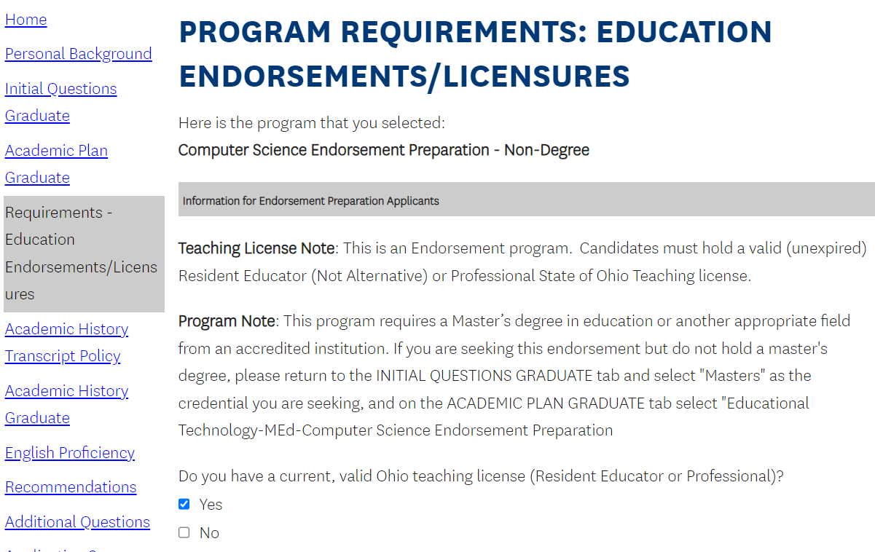
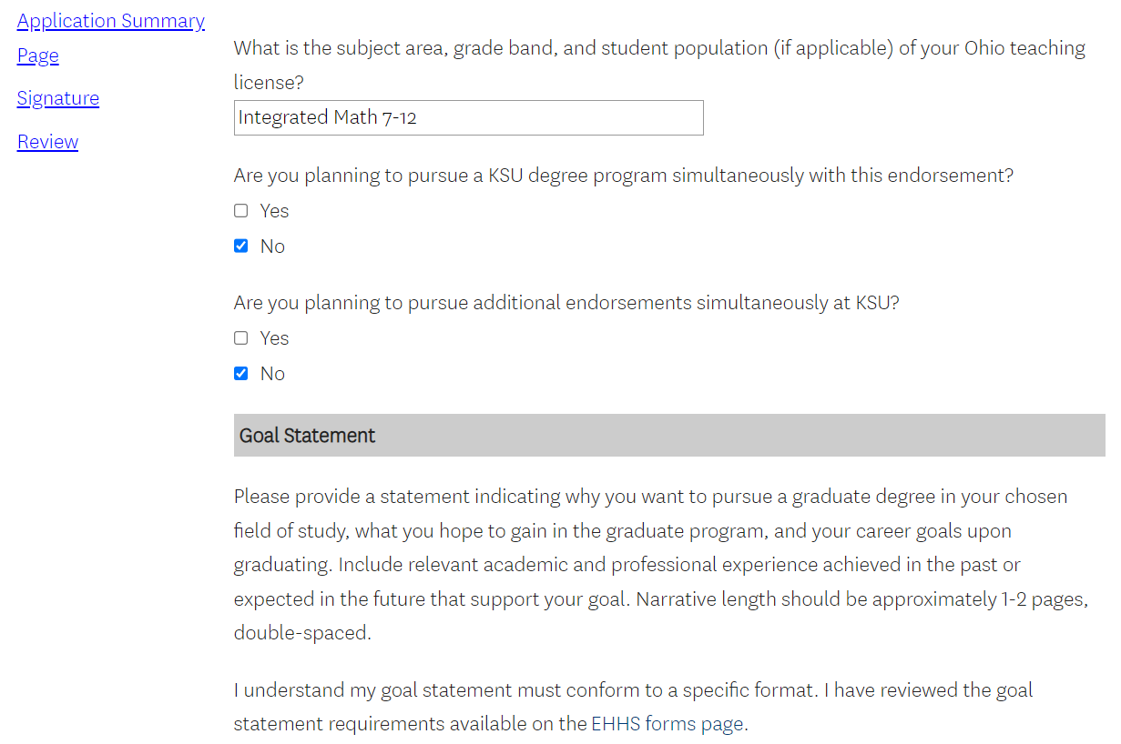
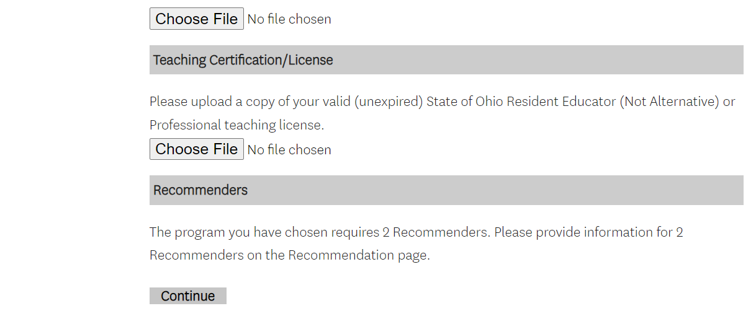
Under the “Recommendations” tab-click on “Add New”. It is required you use the online recommendation system by clicking the box “to be submitted electronically” and then typing in the information needed. The system will automatically generate an email to the listed recommenders requesting a letter be uploaded and/or completion of the included recommendation form. If your recommender chooses to email the letter of recommendation, you must check that option and type in the information of the recommender(s). Letter of recommendations should be emailed directly from the recommender to GRADUATE ADMISSIONS at gradapps@kent.edu.
Letter of Recommendation Information:
- Your application must also include two letters of recommendation; one of those must be from an administrator who is able to address why CS is important to the school/district and the role they see you playing in positively impacting CS in the school/district (i.e., teaching).

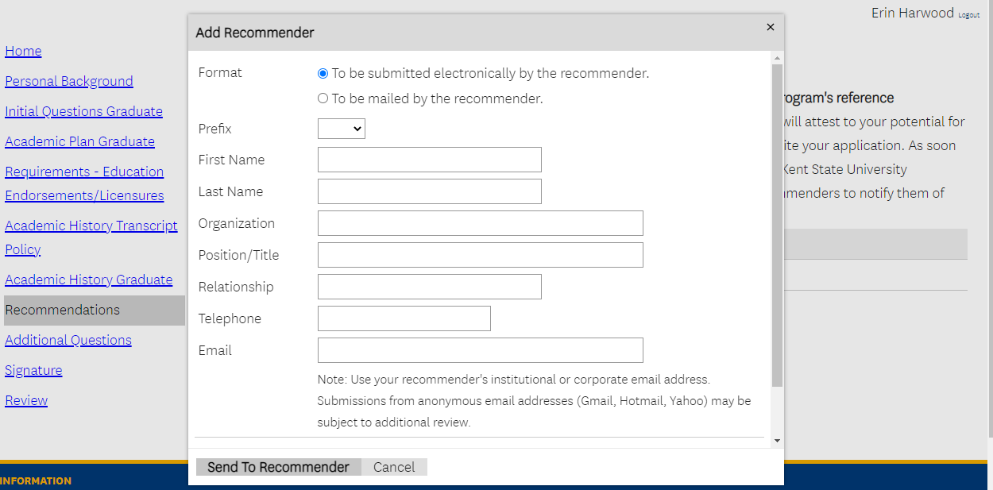

The academic program requirements are built into the application and applicants will not be reviewed for admission until after they have fulfilled all the application requirements. Once you submit your application and pay the application fee ($25, nonrefundable) you will no longer be able to edit the application. However, you can upload your admission documents at a later time (copies* of OFFICIAL transcripts; goal statement, etc) through the Application Status page (available once you submit your app/app fee). Please be aware that your application will not be forwarded to the College of EHHS for review until all outstanding requirements have been satisfied.

*If you upload copies of transcripts during the application process and accept an offer of admission to the program, you will be required to request and submit OFFICIAL transcripts to be sent from ALL degree-conferring institutions by the 2nd week of the student’s first semester or a registration hold will be placed on the student’s record.

