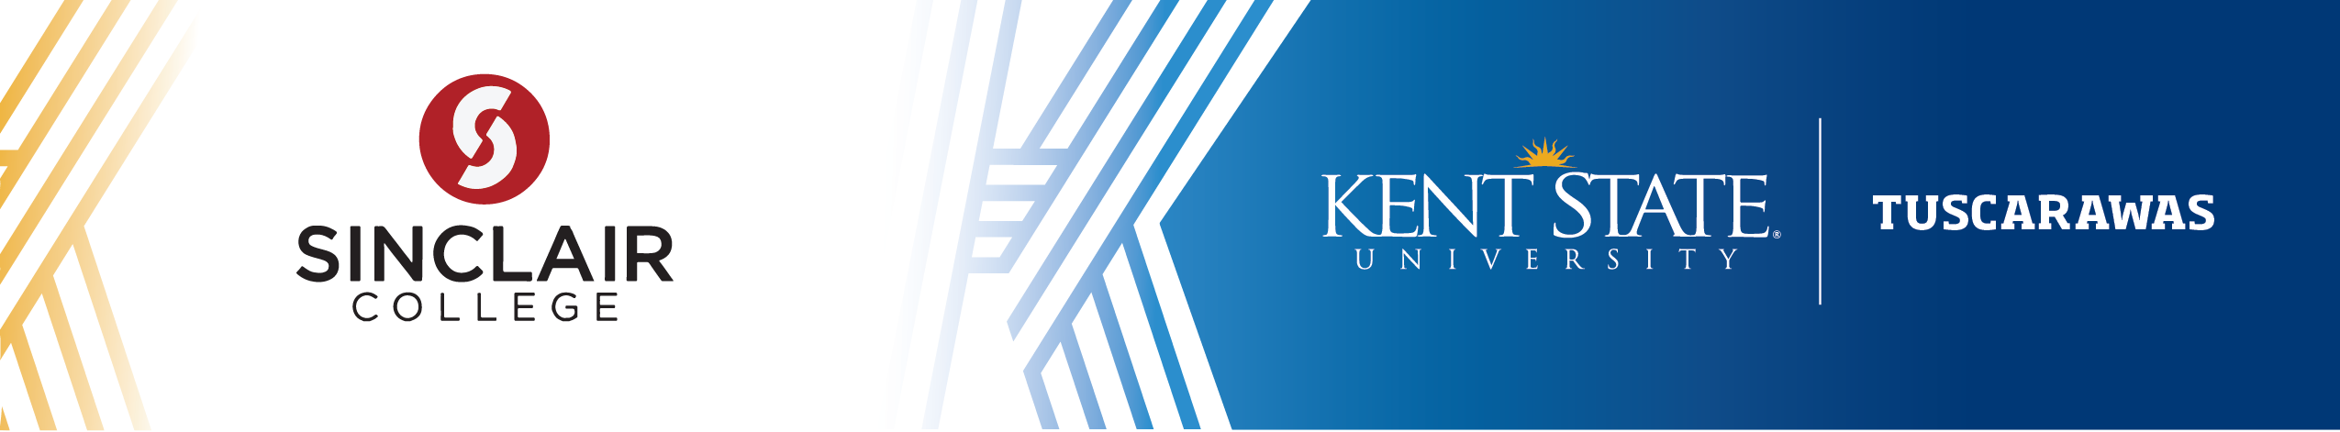

Associate of Applied Science in Legal Studies to Bachelor of Art in Paralegal Studies

REQUIRED COURSEWORK AT SINCLAIR COLLEGE
Course Subject and Title | Credit  Hours | Upper  Division | Notes on Transfer Coursework to Kent State
BIS 1120 Introduction to Software Applications | 3 |  | CIS 24053
COM 2206 Interpersonal Communication | 3 |  | COMM 20001
ENG 1101 English Composition I | 3 |  | ENG 11011 (KCMP1)
ENG 1199 Textual Editing | 3 |  | ENG 1X000
ENG 1201 English Composition II | 3 |  | ENG 21011 (KCMP2)
LAW 1101 Business Law | 3 |  | FIN 26074
Legal Studies Electives | 6
MAT 1120 Business Mathematics  or OT36 Mathematics Elective ¹ | 3 |  | MATH 1X000 or  (KMCR)
OT36 Arts & Humanities Elective | 3 |  | (KFA/KHUM)
PAR 1101 Introduction to Legal Studies | 3 |  | PLST 18000
PAR 1102 Legal Technology | 1
PAR 1103 Litigation | 3 |  | PLST 28004
PAR 1201 Legal Research & Writing | 3 |  | PLST 28001
PAR 1202 Advanced Legal Technology | 1
PAR 1203 Advanced Litigation | 3
PAR 2301 Advanced Legal Research & Writing | 3
PAR 2302 Family Law | 3 |  | PLST 28003 (Legal Specialty Elective)
PAR 2303 Probate Law | 3 |  | PLST 28007 (Legal Specialty Elective)
PAR 2401 Legal Studies Internship | 2 | ■ | PLST 37692
PSY 1100 General Psychology  or SOC 1101 Introduction to Sociology | 3 |  | PSYC 11762 (KSS)  or SOC 12050 (KSS)
RES 1201 Real Estate Law | 3 |  | TRAN 1X000
61 Total Credit Hours to Graduate with the AAS Degree from Sinclair College

¹ Recommended for transfer
SUGGESTED SEQUENCE AT KENT STATE UNIVERSITY
Course Subject and Title | Credit  Hours | Upper  Division | Notes on Transfer Coursework to Kent State
Semester Five: [16 Credit Hours] Kent State University
Legal Specialty Elective | 3 | ■
Kent Core Basic Sciences (KBS) | 3 |  | @
Kent Core Humanities and Fine Arts (KHUM/KFA)** | 3 |  | @
Kent Core Social Sciences (KSS – Not PSYC / SOC) | 3 |  | @
Foreign Language | 4
Semester Six: [16-17 Credit Hours] Kent State University
PLST 38006 Applied Legal Research and Litigation | 3 | ■
Legal Specialty Elective | 3 | ■
Kent Core Humanities and Fine Arts (KHUM/KFA)** | 3 |  | @
Foreign Language | 4
Kent Core Basic Sciences (KBS, KLAB) | 3-4 |  | @
Semester Seven: [18 Credit Hours] Kent State University
Legal Specialty Electives | 6 | ■
Kent Core Additional (KADL) | 6 |  | @
Foreign Language | 3
General Elective, Upper Division | 3 | ■
Summer Semester: [4 Credit Hours] Kent State University
PLST 36792 Internship in Paralegal | 4 | ■
Semester Eight: [18 Credit Hours] Kent State University
Legal Specialty Electives | 6 | ■
Foreign Language | 3
General Elective, Upper Division | 9 | ■
133-134 Total Credit Hours to Graduate with the BA, including transfer coursework, from Kent State University

@ Course may be taken at Sinclair College and transferred to Kent State. However, please be aware of Kent State’s residence policy, which can be found in the Kent State University Catalog.

** Minimum one course must be selected from the Humanities in Arts and Sciences (KHUM) area, and minimum one course must be selected from the Fine Arts (KFA) area. Please consult with an academic advisor.

Graduation Requirements
Requirements to graduate with the BA degree program: To graduate, students must have minimum 120 credit hours, 39 upper-division credit hours of coursework, a minimum 2.000 major GPA and minimum 2.000 cumulative GPA. They must also fulfill an approved experiential learning experience and complete a writing intensive course with a minimum C (2.000) grade. More specific graduation requirement information can be found in the Academic Policies section of the Kent State University Catalog (www.kent.edu/catalog).

This information is provided solely for the convenience of the reader, and Kent State University expressly disclaims any liability which may otherwise be incurred. This publication is neither a contract nor an offer to make a contract. While every effort has been made to ensure the accuracy of the information, Kent State University reserves the right to make changes at any time with respect to course offerings, degree requirements, services provided, or any other subject addressed herein.

It is recommended that students intending to pursue the Bachelor of Arts in Paralegal Studies through Kent State University consult with academic advisors at both Sinclair College and Kent State University.

Contact Information
Sinclair College
Charles Long
Manager of Curriculum, Transfer & Articulation
Provost's Office
937-512-3145
charles.long4574@sinclair.edu
Kent State University
Academic Partnerships
pathways@kent.edu

Last Updated December 2025

