Strange Metals and Black Holes

Professor Subir Sachdev
Herchel Smith Professor of Physics,
Harvard University
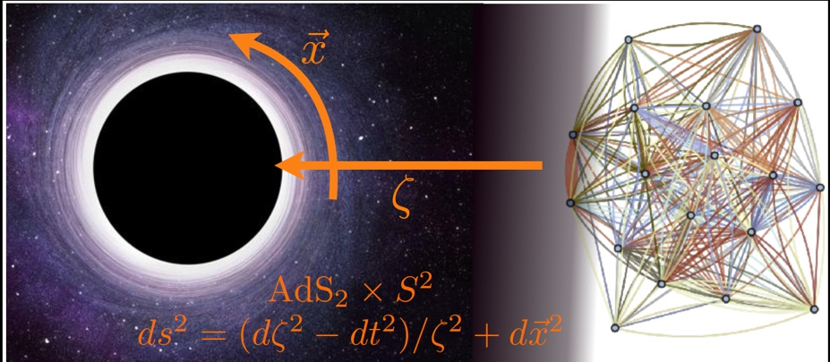

Abstract:
The ‘strange metal’ is a state of matter formed by electrons in many modern materials, including the compounds which exhibit high temperature superconductivity. In this state, electrons quantum entangle with each other and conduct electric current collectively (rather than one-by-one, as in an ordinary metals like copper). Quantum entanglement also has remarkable effects near the horizon of a black hole, leading to the Bekenstein-Hawking black hole entropy, and the Hawking temperature. Surprisingly, there is a deep connection between the nature of quantum entanglement in strange metals and black holes, and this has led to mutually beneficial insights. This connection is simply described by the Sachdev-Ye-Kitaev model, which leads to a common set of equations describing the quantum dynamics of certain strange metals and black holes.

