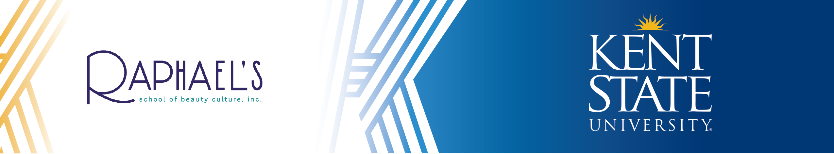
Raphael’s School of Beauty Culture to The Associate of Technical Study, Individualized Program

Raphael’s School of Beauty Culture: Certificate Program

Kent State University: Associate of Technical Study, Individualized Program

Course Subject and Title | Credit  Hours | Upper  Division | Notes
Raphael’s School of Beauty Culture
Certificate Program Completion | 30 |  | Documentation of certificate program completion. Certificate program hours must be greater than or equal to 1,000 clock hours.
Semester One: [15-16 Credit Hours] Kent State University
ENG 11011 College Writing | 3 |  | Fulfills Kent Core Composition
Kent Core Requirement | 3 |  | Consult with an Academic Advisor
General Electives | 9
UC 10001 Flashes 101 | 1 |  | UC 10001 is not required of transfer students with 30 credits (excluding College Credit Plus) or students age 21+ at the time of matriculation.
Semester Two: [15 Credit Hours] Kent State University
Kent Core Requirement | 3 |  | Consult with an Academic Advisor
Kent Core Requirement | 3 |  | Consult with an Academic Advisor
Kent Core Requirement | 3 |  | Consult with an Academic Advisor
General Electives | 6
60-61 Total Credit Hours to Graduate with the ATS Degree from Kent State University

GRADUATION REQUIREMENTS SUMMARY

Minimum Total Hours: 60 credit hours
Minimum Kent Core Hours: 15 credit hours
Minimum Major GPA: 2.000
Minimum Overall GPA: 2.000

Students must successfully complete 15 credit hours of graded Kent State coursework required for the A.T.S. degree before receiving any college credit for industry recognized licensures, certifications, or diplomas.

The Associate of Technical Study degree, Individualized Program, is open to students who need a specially designed course of study in a technical field. The program consists of courses that suit the students' career goals. Course requirements are planned with the help of a faculty advisor and must be approved by the dean of the College of Applied and Technical Studies.

Contact Information
Raphael’s School of Beauty Culture, Inc.
330-782-3395, ext 1113
BDelserone@raphaelsbeautyschool.edu

Kent State University
Academic Partnerships
pathways@kent.edu

Last Updated December 2025

