How to Use a Food Processor

The Blades

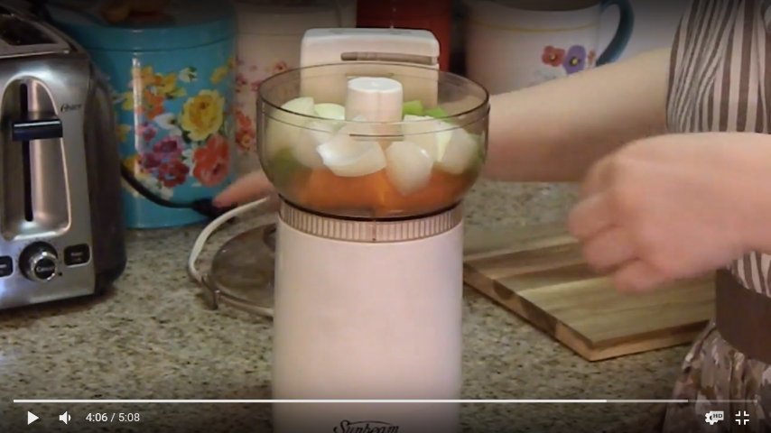Loading

\* Cut food into bite-size pieces so that

they easily fit into the bowl. This will

help avoid jams

\* Use the pulse to chop and grind.

continue pulsing until the desired

consistency is reached

\* Use the continuous option to puree,

slice, or shred

\* Some food processors will not have

on/off/pulse buttons. For these models,

the lid often serves as the on/off. It is

activated by fitting the lid into a slot

\* Food processors are best for making

foods no wetter than a paste. For recipes

with a lot of liquid, like a smoothie, a

blender will work better.

