For formal admission to the SPED Licensure Preparation programs, you will need to complete the online graduate application and its requirements by clicking on “Apply Now” or “Graduate non-degree Application”.

Hints on answering application prompts correctly:
- Page 1-Begin Application-“for which type of program are you applying”-SELECT “LICENSE”

- Page 7-Intended Program-SELECT “COLLEGE OF EDUCATION, HEALTH, AND HUMAN SERVICES”
Then SELECT your intended SPECIAL EDUCATION LICENSURE PREP program option:
        - If you currently hold a valid (unexpired) 4 Year Resident Educator or 5-Year Professional State of Ohio teaching license, you SELECT “….ADDITIONAL LICENSURE PREPARATION” and the term you plan to start coursework
        - If do NOT currently hold a valid (unexpired) 4-Year Resident Educator or 5-Year Professional State of Ohio teaching license, you SELECT “…INITIAL LICENSURE PREPARATION” and the term you plan to start coursework
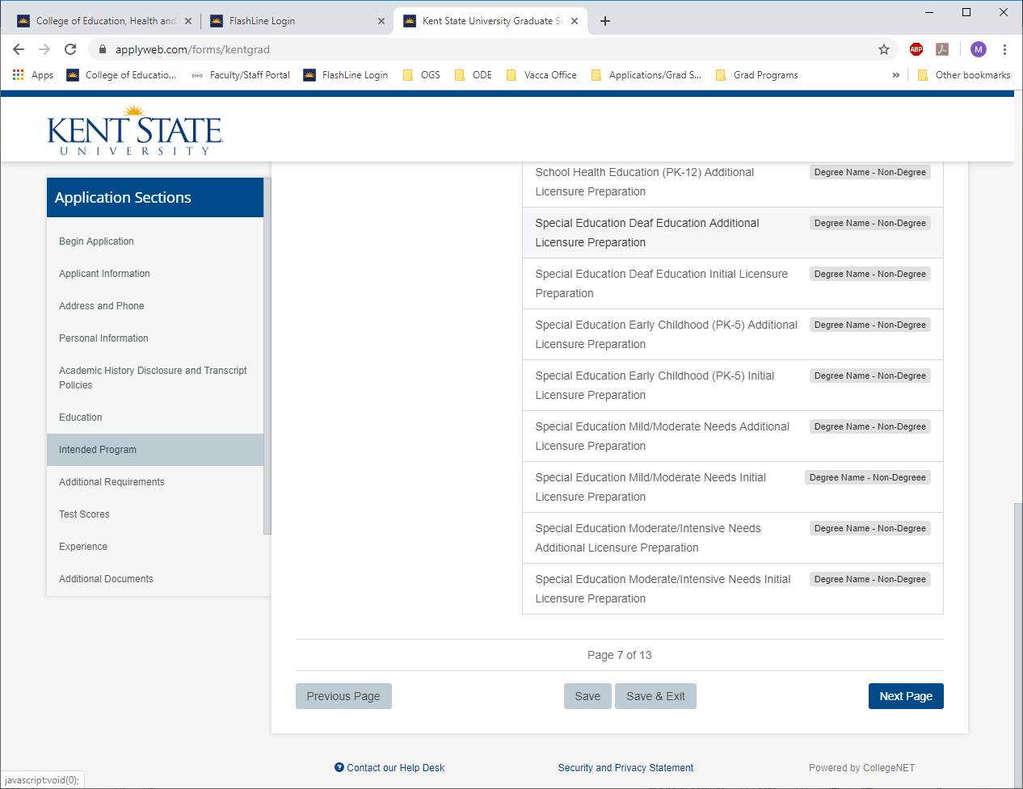

- Page 8-Additional Requirements-Identify if you are seeking initial or additional teacher licensure (see above-the Praxis Core Exams are required for Initial Licensure Prep). SELECT “YES” if you are also applying to the Master’s of Special Education simultaneously or SELECT “NO” if you are only seeking licensure. SELECT “NO” for pursuing additional licenses simultaneously.

