Folding Options

Single Fold Mailpiece Letter Fold Mailpiece/letter
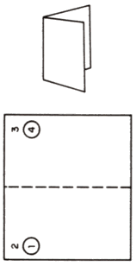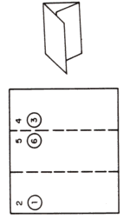

Fan Fold Mailpiece/letter Double Parallel Fold
(not machine insertable) (double pass through folder)
