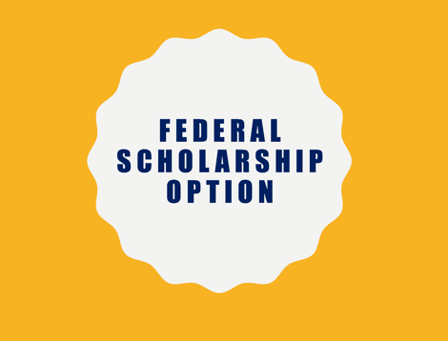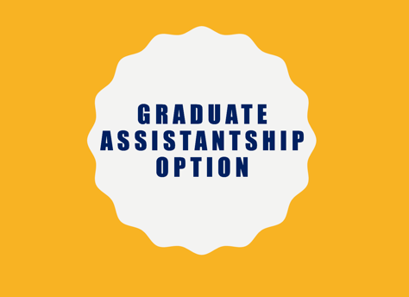 

­For more details, visit our website at:

www.kent.edu/ehhs/ldes/sped/early-intervention-certificate

**__**

**CONTACT INFORMATION**

Dr. Sanna Harjusola-Webb, PhD | shwebb@kent.edu | (330) 672-0585

**PROGRAM DESCRIPTION**

The Early Intervention Certificate Program is designed to provide an interdisciplinary training for future professionals in special education and speech pathology to serve families of infants and toddlers with developmental delays or disabilities in home and community settings. expand the university’s interdisciplinary training and collaboration across the entire curriculum for professionals seeking expertise in Speech Pathology/Audiology and Early Intervention.  KSU scholars who graduate from the program will qualify for the Ohio Department of Health issued Early Intervention Certification and will enter the field highly qualified to support families with infants and toddlers with disabilities in Part C systems

The following options are available:

**FEDERAL SCHOLARSHIP OPTION** (through 2021-2022)

* One-year, full-time plan of study (Fall, Spring, Summer)
* Tuition waiver and monthly stipend
* Two-year service obligation after completion of program (employed position involving direct services to infants and toddlers with disabilities)

**GRADUATE ASSISTANTSHIP OPTION**

* Full-time plan of study (12 credit hours per semester)
* 20 hours per week of department work (assistantship)
* Tuition waiver and stipend
* No service obligation required

**PART-TIME PLAN OF STUDY OPTION**

* 3, 6, or 9 credit hours per semester
* No tuition waiver or stipend, but other sources of financial aid may be available

**EARLY INTERVENTION CERTIFICATE**

GRADUATE-LEVEL

PROGRAM OPTIONS: