University College Dress Code

Maintaining a professional appearance is important to the success of University College. As employees of a unit that interacts with all members of the Kent State community and beyond, we are all responsible for our collective reputation.
University College professional staff members are expected to wear business attire. Graduate and undergraduate student staff is welcome to wear appropriate casual attire. Regardless of the role, UC staff members should avoid wearing leggings as pants; strapless or halter tops; rubber flip flop shoes; or spaghetti straps. Staff is permitted to wear jeans on Fridays.
On Fridays, all UC staff members are encouraged to show their KSU and UC pride. To demonstrate our KSU and UC pride, professional and graduate staff should only wear Kent State or departmental affiliation shirts and sweatshirts. Undergraduate students are allowed to wear Kent State, other departmental affiliation, and fraternity or sorority shirts and sweatshirts.
If you have questions or concerns about the interpretation of this dress code, please consult your direct supervisor. Graduate staff must check with their supervisor for information on appropriate attire for their role within their department.
Review the examples of do’s and don’ts attire for University College.

Do’s and Don’ts Attire for University College
Do wear clothes that have a professional or business casual look.
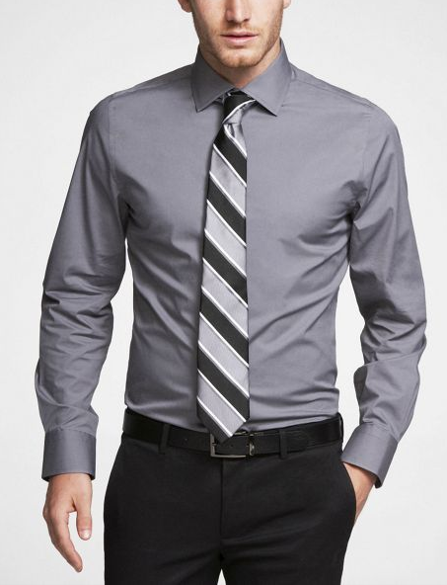
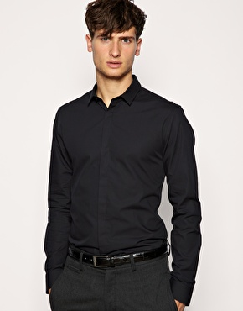

Do wear Jeans and KSU/University College shirts on Fridays.
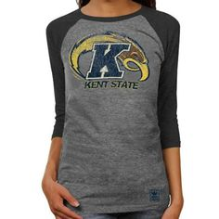
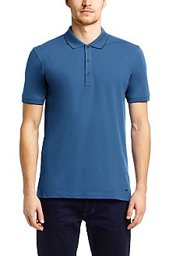

Don’t wear rubber flip flops or t-shirts/sweatshirts that are not KSU/University College.
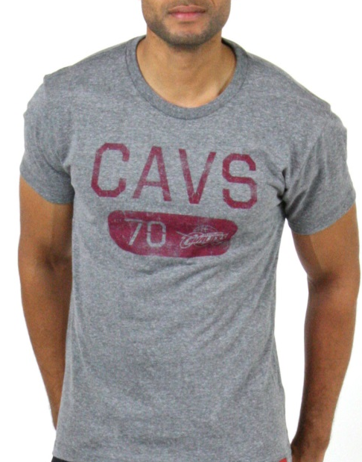
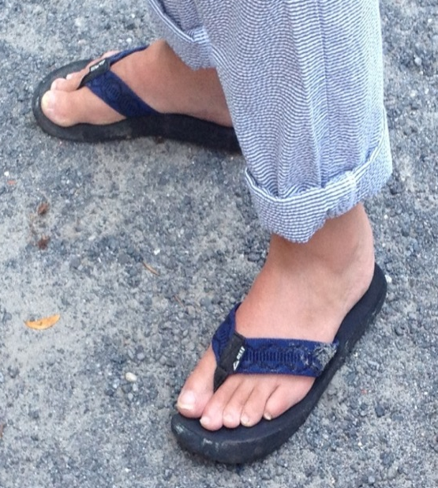

Don’t wear leggings as pants or wear halter tops or spaghetti straps.
