Chicken Quesadilla with Avocado Salsa
Ingredients
Quesadilla:
2 whole grain tortillas
½ C grated zuccini
½ C shredded chicken
¼ C corn
½ C 2% cheddar cheese

Avacado Salsa:
4 T. salsa verde
½ avacado
1 T. lime juice

Makes 2 Servings Prep-time: 10 minutes
1. To peel the avocado, slice down the top of the avocado until you reach the pit. Continue slicing in a circle until you have made it completely around the avocado. Grab the avocado on either side of the cut and twist. Once the avocado is split, grip the thin end of the avocado and carefully drive your knife into the pit. Twist until the pit comes out of the avocado.
2. Use your knife to slice a grid into the flesh of the avocado. Take care not to press too hard and pierce the skin. Take a spoon around the rim of the avocado and scoop it out.

3. Place the avocado in a medium bowl along with the salsa and lime juice. Use a fork and mash the avocado chunks until you reach your desired consistency
4. On one tortilla evenly layer: ½ of the cheese, all of the zucchini, all of the chicken, and all of the corn. Top with the remainder of the cheese. Place the other tortilla on top.
5. Spray a pan with cooking spray and heat over medium high heat for about three minutes. Once the pan is hot, cook the quesadilla for two minutes on each side or until it is crispy and golden brown.
6. Cut the quesadilla into eight pieces and enjoy with the avocado salsa!
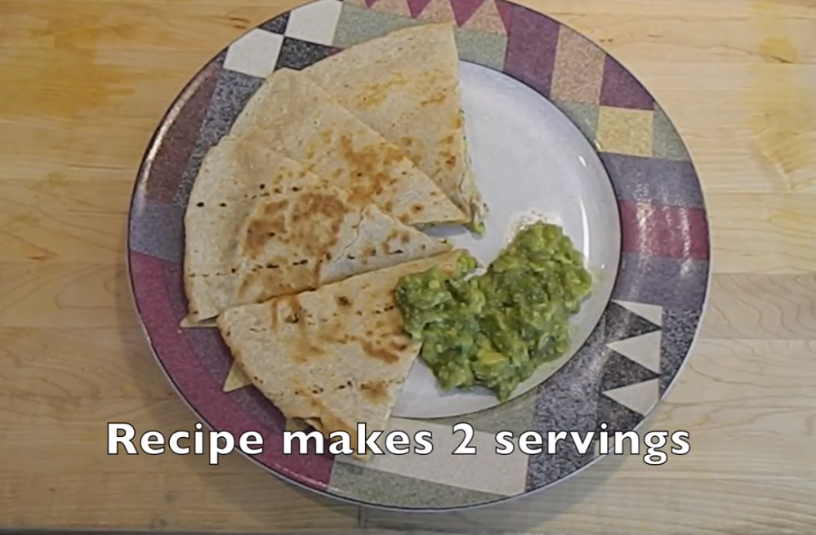

This recipe is:
- Excellent source of calcium
- A good source of fiber

