Giving Tuesday Crowdfunder Guide

Select a featured fund at www.kent.edu/GivingTuesday that you are passionate about, then:
- Click “Become A Fundraiser.”

- Select whether you are part of a team or an individual (if the team option is available).

- “Log In” or “Create an Account.”

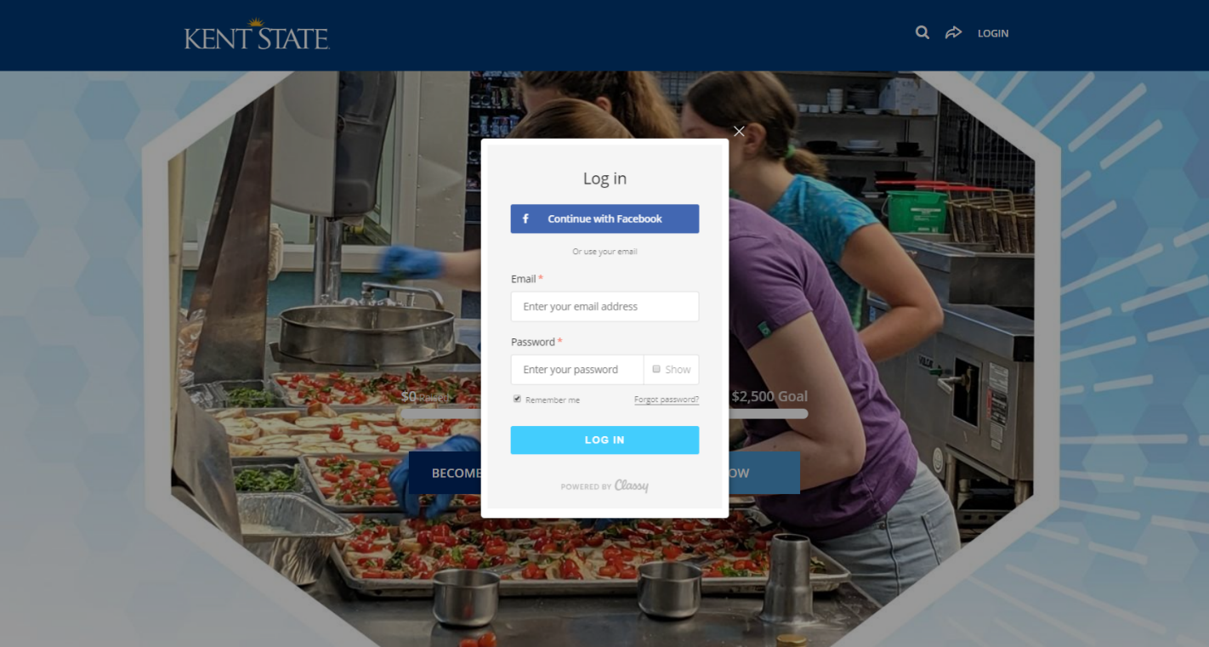

- Create a fundraising goal, personalized headline, and URL (Optional).
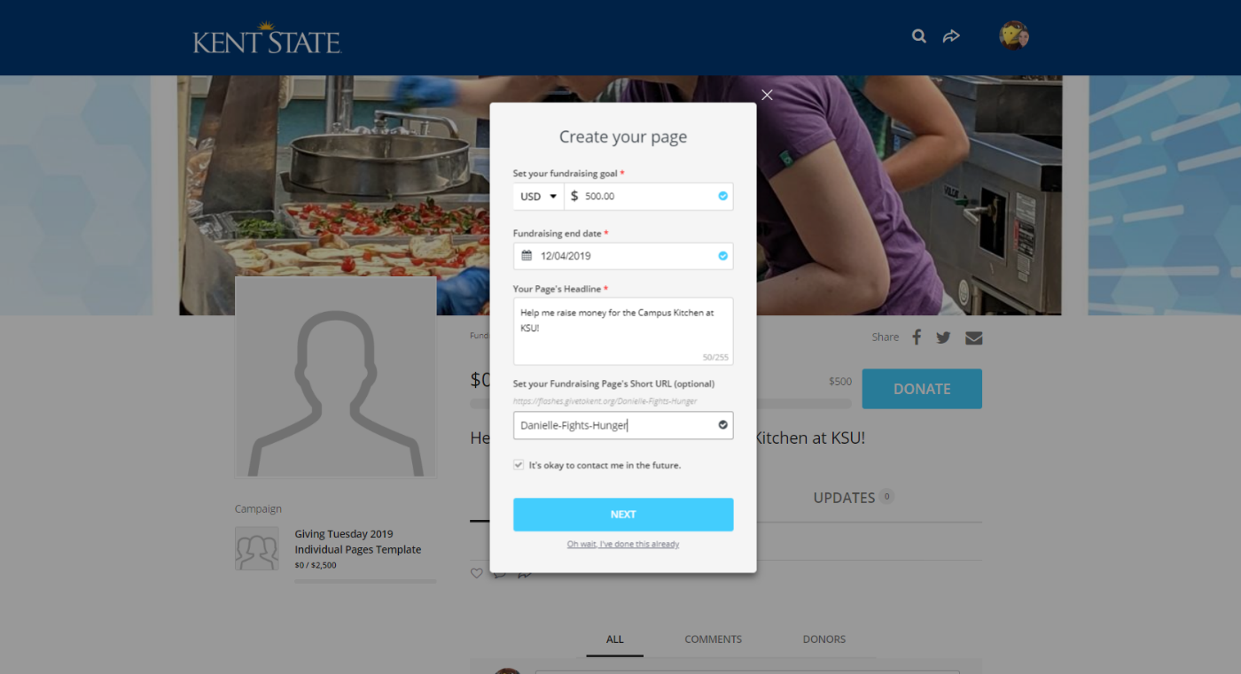

- Add profile photo

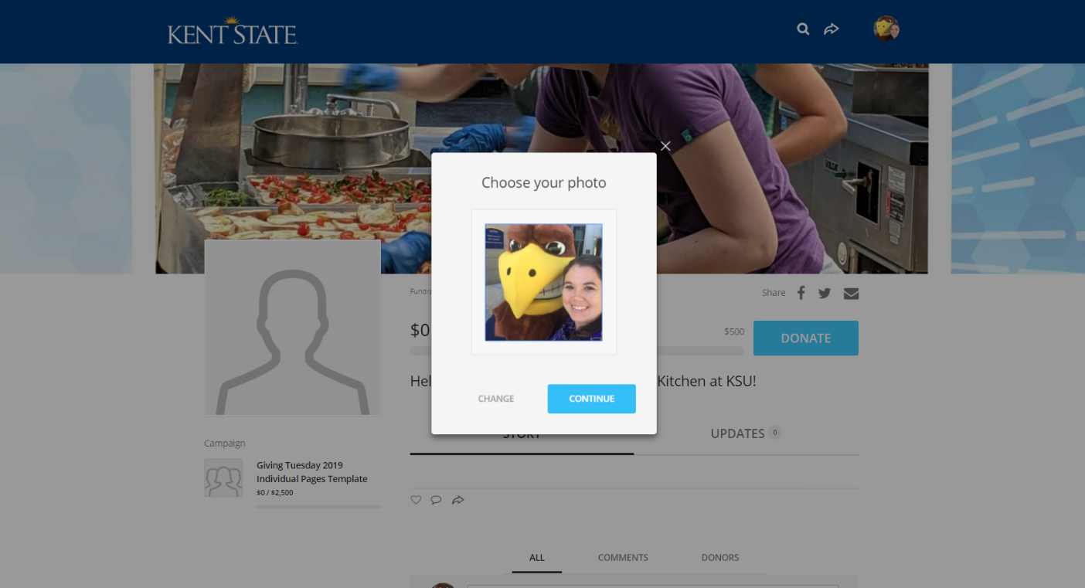

- Nice work!

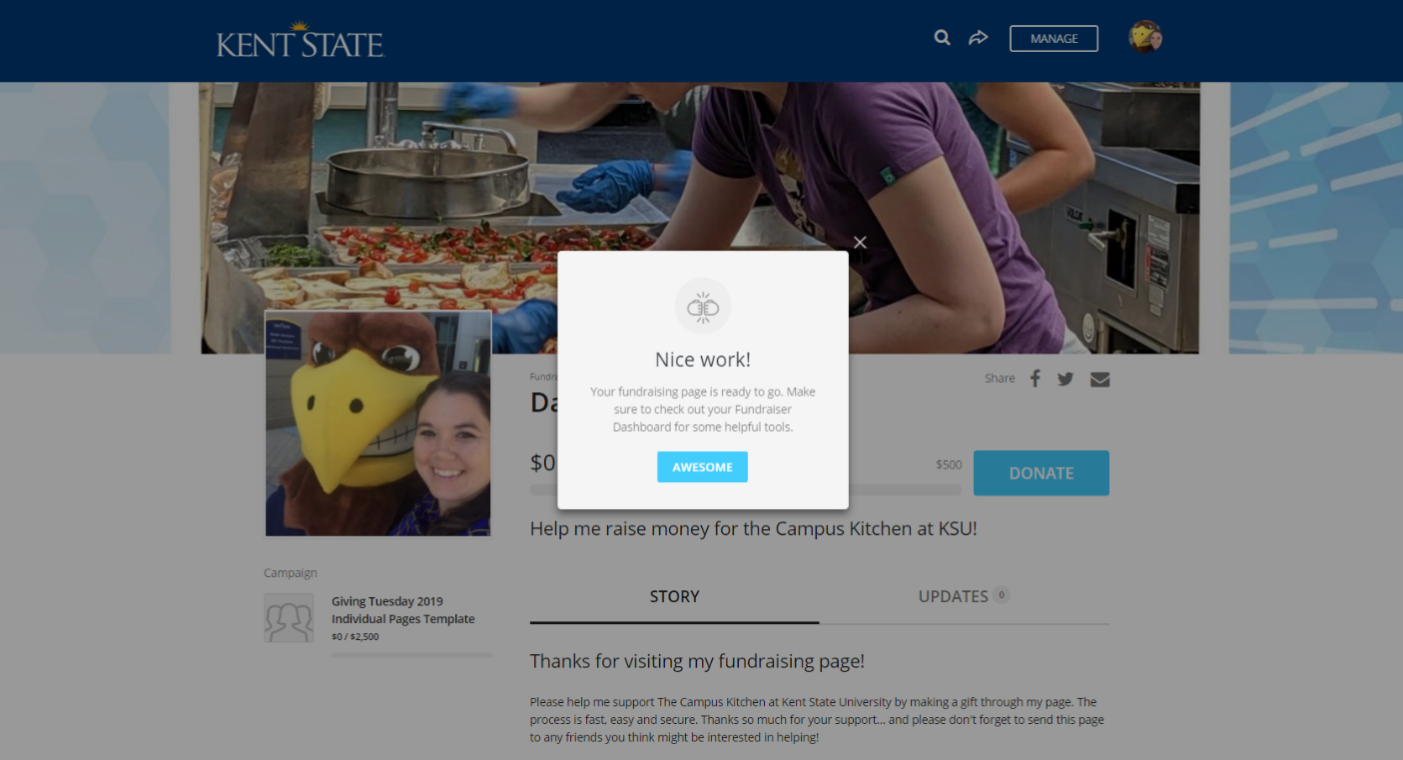

- Use “Share” Buttons at top right of your profile and send to friends and family.
  - E-mail friends your profile page by clicking the button that looks like an envelope to family or friends.
  - Share your page to the social media by clicking the Facebook and Twitter icons. If you access your profile on a mobile device, you can text your profile to someone using the “Share” button.

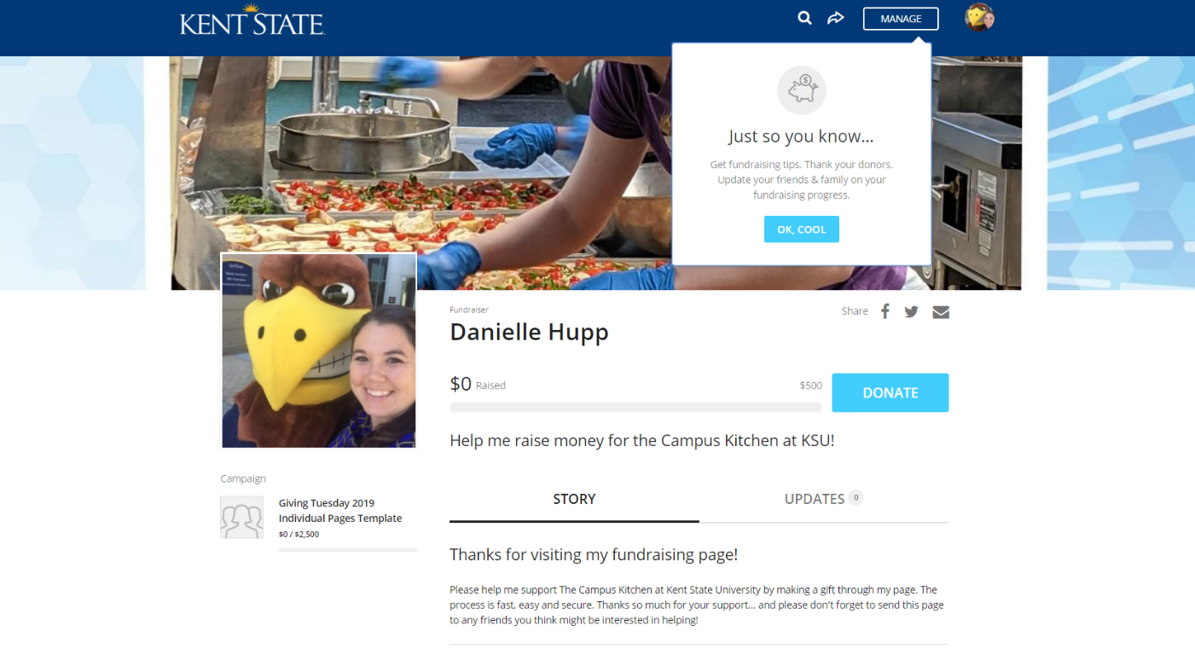

Other Resources:

- Once your profile has been created, use the “Manage” button at the top-right of your profile to update and personalize your crowdfunding story (Talk about the impact of the campaign and how it will benefit students).
- You have the ability to add photos or videos as well using the toolbar at the bottom of the story box.
- If you wish to edit your page headline, profile photo, and increase your goal, select the “Details” section.
- You can personally thank donors to your campaign by selecting the “Donations” button at the top.

Questions? Contact Danielle Hupp, drhupp@kent.edu.

