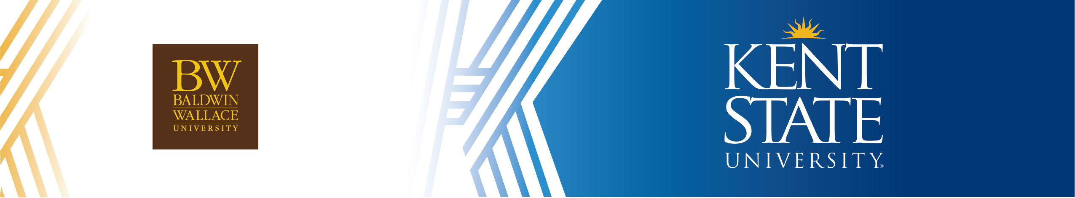
BS in Pre-Allied Health/Pre-Physical Therapy or Exercise Science to MS in Athletic Training

This Agreement between Kent State University and Baldwin Wallace University enables Baldwin Wallace University qualified students to complete the Bachelor of Science in Pre-Allied Health/Pre-Physical Therapy or Exercise Science at Baldwin Wallace University and receive preferred admission to Kent State University for its Master of Athletic Training (2-year option). The Kent State University Master of Science in AT is accredited by the Commission on Accreditation of AT (CAATE) and Kent State University is accredited through the Higher Learning Commission.
LIST OF PRE-REQUISITES AND COURSE EQUIVALENCIES FOR ARTICULATION
Kent State University  MSAT program prerequisites | Baldwin Wallace University  Equivalent Courses | Credits
Biology | BIO 121 Fundamentals of Cellular and Molecular Biology ¹ or BIO 122 Fundamentals of Ecology, Evolution and Biodiversity with lab ¹ | 4 cr
Basic Athletic Training | ASW 202 Principles of Sports Medicine ¹ | 3 cr
Kinesiology or Biomechanics | ASW 402 Kinesiology/Biomechanics ¹ | 3 cr
Human Anatomy and Physiology I | BIO 203 Human Anatomy and Physiology I (Includes lab) ¹ | 4 cr
Human Anatomy and Physiology II | BIO 204 Human Anatomy and Physiology II  (Includes lab) ¹ | 4 cr
Exercise Physiology | ASW 302 Physiology Of Exercise ¹ | 3 cr
General Chemistry and Lab | CHM 111 General Chemistry I ¹  (note: course does not inc. lab) | 4 cr
Research | ASW 209 Research Design & Statistics in Sport Sciences ¹ | 3 cr
Physics I and Lab | PHY 145 Applied College Physics I (includes lab) ¹  or PHY 146 Applied College Physics II (includes lab) ¹ | 5 cr
Nutrition | ASW 211W Nutrition for the Athlete ¹ | 3 cr
Psychology | PSY 100 Principles of Psychological Science ¹ | 3 cr

The Master of Science degree in Athletic Training prepares graduates for the athletic training profession. The program emphasizes both ethics and research across the curriculum to integrate theory to practice and is designed to facilitate inter-professional practice as athletic trainers engage actively with professionals across the health care disciplines.

The Exercise Science major is designed to provide an opportunity for students to acquire theoretical and practical knowledge and develop skills related to exercise science, fitness management and strength and conditioning as they pertain to management and organization of corporate, community, or commercial fitness and health promotion and/or rehabilitation programs. Students successfully completing this major will be prepared as “competent entry-level Exercise Science professionals in the cognitive, psychomotor and affective learning domains” which will be demonstrated in the ability to conduct fitness testing and implement exercise programs for low- to moderate-risk clients and for individuals with controlled diseases. In addition, development of strength and conditioning programs for clients and athletes is also a focus for the major. Students completing this major must take an NCCA-accredited Exercise Science national exam prior to graduation with a preference for the American College of Sports Medicine or National Strength and Conditioning Association.

The major in Pre-Allied Health/Pre-Physical Therapy is designed to provide a strong foundation in the fundamental principles of allied health science. The major offers the preparation necessary for continued study toward a degree in a related allied health profession. Students who complete this program can pursue further education in Physical or Occupational Therapy, Physician Assistants, Athletic Training, Chiropractics, Podiatry and Nursing.

Admission Requirements
Kent State University participates in the Athletic Training Centralized Application System (ATCAS) through the Commission on Accreditation of Athletic Training Education. Applicants to Kent State's program must apply via ATCAS.
- Bachelor’s degree from an accredited college or university
- Minimum 2.750 undergraduate GPA on a 4.000-point scale
- Completion of prerequisite courses with minimum C grade ¹

- Official transcript(s)
- Goal statement
- Two letters of recommendation
- English language proficiency - all international students must provide proof of English language proficiency (unless they meet specific exceptions to waive) by earning one of the following:²
  - Minimum 94 TOEFL iBT score
  - Minimum 7.0 IELTS score
  - Minimum 65 PTE score
  - Minimum 120 DET score

¹ Applicants are expected to have substantial preparation in the sciences, usually including coursework in biology, basic athletic training, biomechanics, anatomy and physiology (including exercise physiology), chemistry, research, physics, nutrition and general psychology. Prerequisites are evaluated for course content to ensure appropriate applicability for the program. Due to the program’s highly prescriptive requirements, students cannot transfer in coursework directly into the Athletic Training major.

² International applicants who do not meet the above test scores may be considered for conditional admission.

For more information about graduate admissions, please visit the Graduate Studies admission website.

Contact Information
Baldwin Wallace University
Karyn A. Gentile
Associate Professor
kgentile@bw.edu

Kent State University
Academic Partnerships
pathways@kent.edu

Last Updated April 2026

