


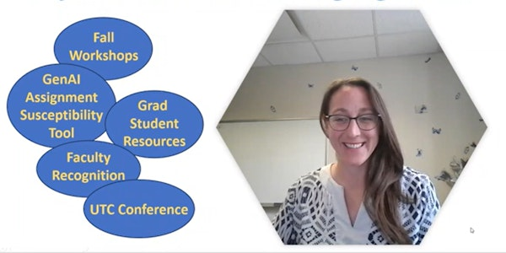



September Highlight Reel

  
  Finding the WhY in Joy
  Friday, September 11th 9:15a - 10:30a
  Microsoft Teams
  The pace of change in our classrooms has accelerated; are your students and classroom tasks feeling unrecognizable? Have you felt changes in yourself as well? It may be time to rediscover the reasons you found yourself in a teaching career. Join us to explore our aspirations, the value we are uniquely qualified to bring to the classroom, and how to protect our joy in teaching.
  Click here to register for Finding the WhY in Joy

  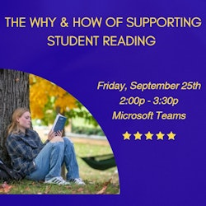
  The Why and How of Supporting Student Reading
  Friday, September 25th 2:00p - 3:30p
  Microsoft Teams
  It’s hard to miss alarmist headlines asking, “Is this the end of reading?” While perceptions that students don't’/can’t read aren’t new, challenges like AI-generated summaries are new. In this session, we’ll consider what research says about our perceptions of student reading, and we’ll think about student reading through the lens of motivation research/theories. Finally, we’ll offer strategies for supporting students’ reading for understanding (and not just for completion).
  Click here to register for Why and How of Supporting Student Reading

  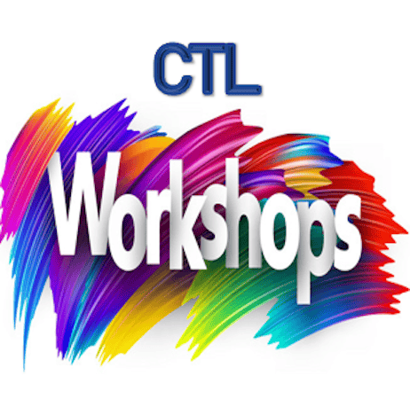
  Upcoming Fall Workshops
  - Play with Purpose: Designing Joyful Learning Experiences
    - Tuesday, October 6th 12:00p - 1:00p - Hybrid Teams/In Person
  - Collaboration by Design: Helping Students Work Better Together
    - Thursday, October 22nd 1:00p - 2:30p - Microsoft Teams
  - Reclaiming Joy: Teaching in the Age of GenAI
    - Friday, November 13th 11:00a - 12:00p - Microsoft Teams
  Click on the title of the workshop to find a full description and register OR visit our website events page by clicking here.

  
  GenAI Assignment Susceptibility Tool
  Use this quick tool if you want to quickly gauge the likelihood of students using GenAI as an alternative means or shortcut to finish your assignment.
  Click here for more Generative AI Teaching Resources.

  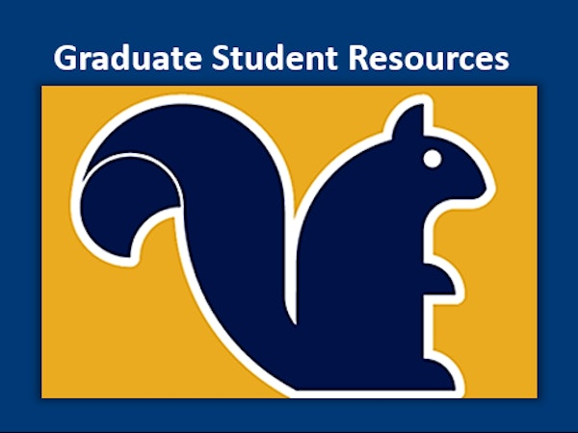
  Graduate Student Resources
  Are you a graduate student at Kent State? Do you know a graduate student who would appreciate opportunities to learn more about teaching and learning? Whether or not you're teaching right now, the CTL has resources for you, featuring a Canvas course with badges (micro credentials) on foundational teaching topics.
  Click here for resources related to Graduate Student Teaching or feel free to reach out to Adam Smith, Ph.D., Professional Development Specialist with Center for Teaching and Learning and University Colleges at asmit615@kent.edu.

  
  September Featured Educator
  Jacquelyn Bleak, Associate Lecturer
  Peace and Conflict Studies
  Kent Campus
  Professor Bleak is being recognized for teaching approaches that model the importance of mediation and negotiation. Their teaching and mentoring of students include a strong emphasis on inclusive conversation.
  Submit Your Nomination Here for a colleague or yourself today!

  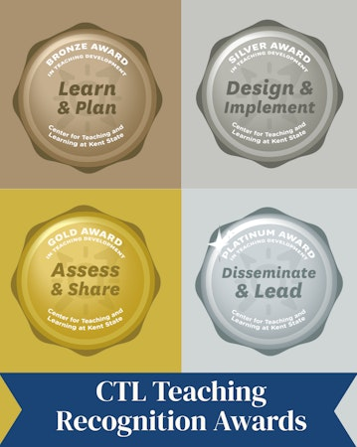
  The Teaching Recognition Awards Program recognizes actions that enhance teaching and learning at Kent State University.
  The objective of the teaching development awards program is to recognize actions that enhance teaching and learning at Kent State University. The program allows instructors to earn tiered awards (bronze, silver, gold & platinum) for their efforts to learn about, implement, evaluate and investigate evidence-based instructional practices. All instructors at Kent State, including graduate students and faculty of all appointment types (TT, NTT, adjunct) are eligible to participate.
  Click here to learn more about the TRA Program and participate

  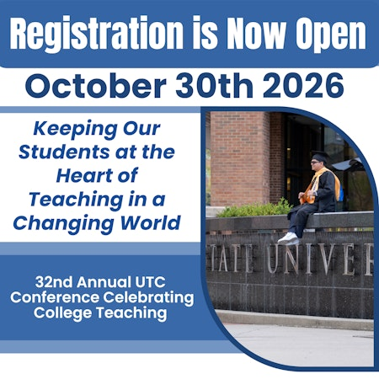
  Join Us for the 32nd Annual UTC Conference Celebrating College Teaching
  "Keeping Our Students at the Heart of Teaching in a
  Changing World"
  Friday, October 30, 2026
  8:30a - 4:00p
  KSC Ballroom
  View More Information and Register by clicking here

  
  Did You Know?
  Many students find belonging through participating in student organizations. The Center for Student Involvement is here to help students get involved outside of the classroom. From events and student organizations to leadership development, the Center for Student Involvement has something to engage students almost every night of the week.
  Help your students find an organization on their campus by sharing the links below:
  Campus Specific Student Organizations/Clubs – Support student belonging
  Stark: https://www.kent.edu/stark/student-involvement
  Salem and East Liverpool: https://www.kent.edu/columbiana/clubs-and-organizations
  Geauga: https://www.kent.edu/geauga/campus-life
  Tuscarawas: https://www.kent.edu/tusc/clubs
  Ashtabula: https://www.kent.edu/ashtabula/student-life
  Trumbull: https://www.kent.edu/trumbull/student-life
  Kent: https://www.kent.edu/csi/student-organizations

Center for Teaching and Learning
250 Hilltop Dr./ Suite 220
330-672-2992
ctl@kent.edu

