



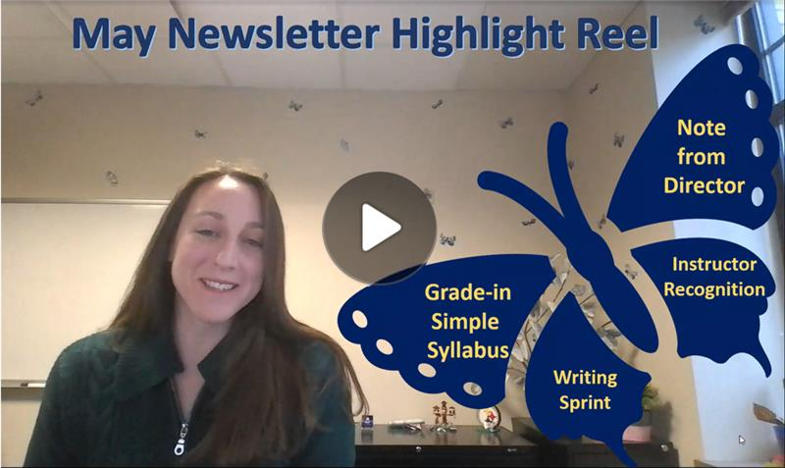

Dear Colleagues,
As summer approaches, I want to say “thank you” for everything you do. It has been an extraordinarily challenging year, and I want you all to know that your efforts do not go unnoticed. I hope that the summer offers you a chance to recharge and be well. Please know that your friends in the Center for Teaching and Learning are here throughout the summer. Please feel free to reach out if you want to connect—we are always happy to see you and to offer support. Read on to check out the things we’ve got in place to support you this summer.
With warm regards,
Jenny

Grading is Better Together
Set aside distractions and grade alongside your peers in a supportive environment. Transform grading from a solitary task into a shared, productive experience. Bring your laptop, assignments and exams and join colleagues for a focused grading time, light snacks, and access to fun breaks.
Please let us know if you plan to attend the Grade-In by clicking here.

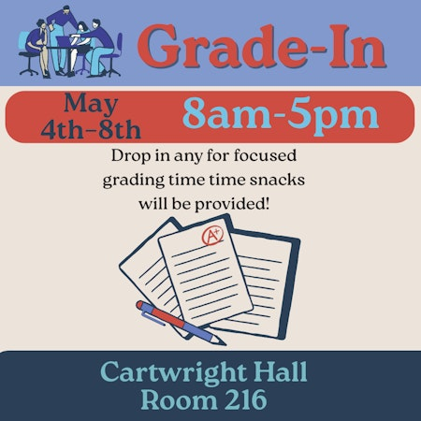


  10-Day Writing Sprint
  Write wherever and whenever you want with asynchronous connections and accountability. Learn more...
  Click here to self-enroll in the June Writing Sprint
  Click here to self-enroll in the July Writing Sprint

  
  Simple Syllabus Training
  Calling all instructors! If you haven’t learned about Simple Syllabus, Kent State’s digital platform for compliance with the SB-1 public syllabus mandate, there are many opportunities to learn. Please consider joining us for one of these sessions. You should also consider checking out the Sharepoint resource site, which includes FAQs , workshop recordings, and more!
  - Tuesday, May 5 noon-1:00 p.m.
  - June 5 noon-1:00
  - July 13 noon-1:00
  - Aug. 3, 10-11:00
  - Aug. 11, 11:00-noon
  - Aug. 20, 9-10:00
  - Aug. 24, 4-5:00

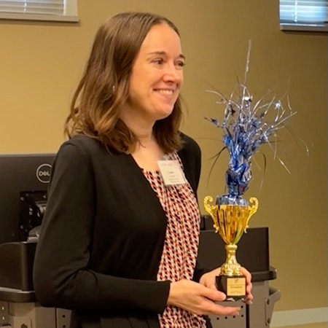
Congratulations to this year's Kent State Teach-Off Winner Kaatie Cooper!
Kaatie Cooper is winner of the 2nd Annual Great Kent State Teach-Off. Kaatie presented a thought-provoking 2-minute presentation on using video response assignments as a way to circumvent AI and get to know your students better. She also designed a recipe to inspire others that can be found by clicking here.

  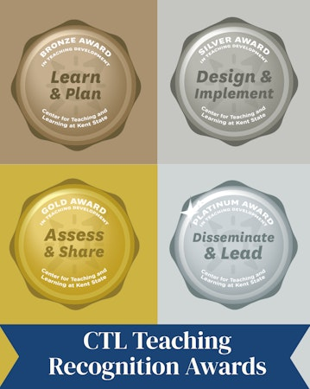
  The Teaching Recognition Awards Program recognizes actions that enhance teaching and learning at Kent State University. Read more....
  Congratulations to the Instructors Who Recently Received Awards:
  Bronze Award Recipients:
  Tina Saunders
  Silver Award Recipients:
  William Bolden III
  Jennifer Visker
  Platinum Award Recipient:
  Rick Ferdig
  Enrico Gandolfi

  
  Interested in Being a Flashes 101 Instructor?
  University College is currently seeking instructors who will support student success by creating a welcoming environment for first-year students.
  Click here to apply to be an instructor

