

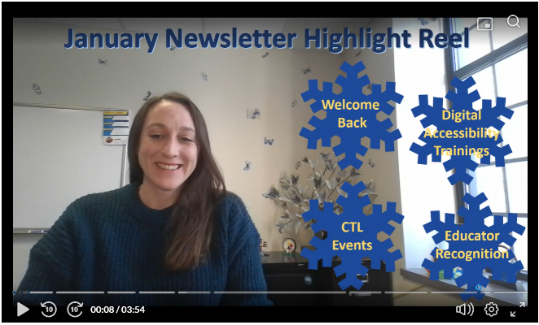

Dear Colleagues,
I hope that your winter break provided you with much-needed time to recharge. I know that many of you are eager to learn more about the new digital accessibility guidelines and gain support in addressing these issues. There are resources in the works that we will share as they become available; however, we already have multiple opportunities for support. Please know that we recognize that this represents an additional lift in your already busy schedules and Kent State is doing our best to support you. See workshop listings below and check out the website for Digital Accessibility https://www.kent.edu/kso/digital-accessibility .
All my best,
Jenny

Digital Accessibility Trainings

Digital Accessibility Training
Topic | Date | Time | Format
Accessible Canvas Courses: Self-Paced Training Course  Learn more about key accessibility principles and practical strategies to design and deliver accessible Canvas courses. | Open Enrollment |  | Self-Paced
New Accessibility Requirements and What They Mean for You  Brief overview of new ADA digital accessibility regulations, as well as resources, considerations, and strategies for digital course materials. The webinar will also discuss a phased approach and timeline for this work. | 1/13/26 | 12pm – 1pm | Virtual  (Teams)
Kaltura Reach: Video Captioning  A Kaltura tool allows for captioning of videos saved in the application. This workshop covers the basics of adding captions with the Reach tool, and discusses best practices for optimizing the effectiveness of the captioning. | 1/15/26 | 12pm – 1pm | Hybrid*
New Accessibility Requirements and What They Mean for You  Brief overview of new ADA digital accessibility regulations, as well as resources, considerations, and strategies for digital course materials. The webinar will also discuss a phased approach and timeline for this work. | 1/16/26 | 12pm – 1pm | Virtual  (Teams)
Topic of the Week: Alternative (Alt) Text  This session will focus on adding alt text to images in Microsoft and Canvas, including what it is, when it’s needed, and how to add it. | 1/20/26 | 12pm – 1pm | Virtual  (Teams)
Microsoft Word Intermediate  This workshop covers more advanced topics like working with Styles, which promote accessible | 1/21/26 | 3:30pm – 4:45pm | Hybrid*
Kaltura Video Platform  This session will provide an in-depth look at the tools and features in the Kent State implementation of Kaltura Video Platform at Video.kent.edu. | 1/23/26 | 9am – 10:15am | Hybrid*
Kaltura Reach: Video Captioning  A Kaltura tool allows for captioning of videos saved in the application. This workshop covers the basics of adding captions with the Reach tool, and discusses best practices for optimizing the effectiveness of the captioning. | 1/23/26 | 10:30am – 11:45am | Hybrid*
Topic of the Week: Color Contrast  Learn how to identify and fix common color contrast issues in Microsoft and Canvas and make simple adjustments that can improve readability and accessibility. | 1/27/26 | 12pm – 1pm | Virtual  (Teams)
*This workshop is presented in a hybrid format: in person in the TechHelp Training Room, Library 152, as well as via Teams meeting.

CTL Spring Semester Workshops

  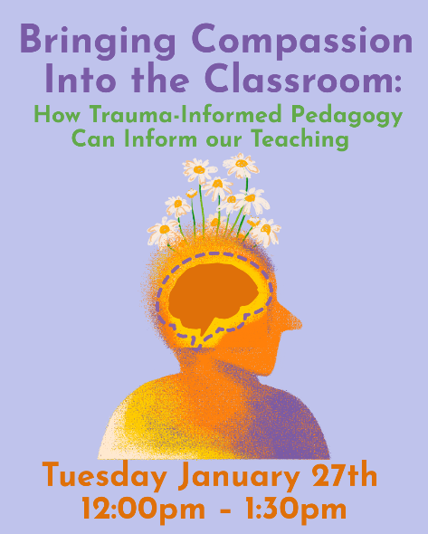
  Bringing Compassion into the Classroom: How Trauma-Informed Pedagogy Can Inform our Teaching
  Tuesday, January 17th
  12:00p - 1:30p
  Microsoft Teams
  This workshop will detail what trauma is, how it shows up in our classrooms, and how it affects students’ ability to learn.

Click here to register for Bringing Compassion to the Classroom

  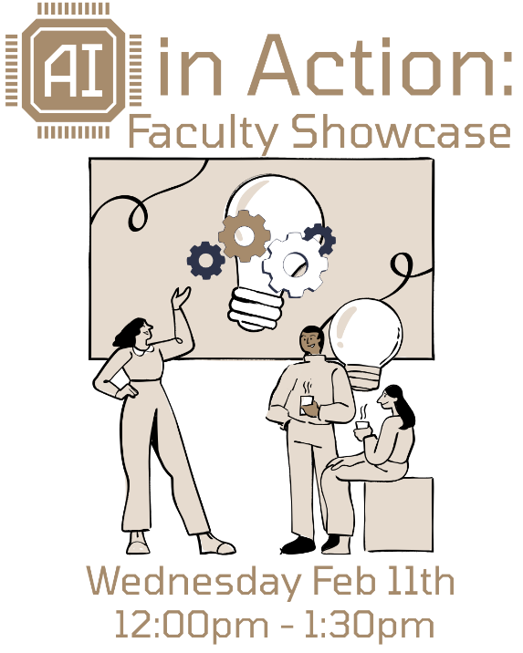
  AI in Action:
  Faculty Showcase
  Wednesday, February 11th
  12:00p - 1:30p
  Microsoft Teams
  Curious how AI can truly support student learning? Join us as faculty share examples of how they’ve integrated AI into their courses to save time, spark student creativity, deepen engagement and enhance critical thinking.

Click here to register for AI in Action: Faculty Showcase

  
  The Great Kent State Teach-Off
  is Back!
  The Great Kent State Teach-Off is a friendly competition where instructors present for 5 minutes on something they do in their courses, such as an activity, technology, tool, assessment, etc. Each instructor will have 5 minutes to share what it is, how it works, and hints on how others can use it. This year we are limiting the number of competitors to 10 and having one competition bracket with no edited videos.
  Learn more about the Teach-Off...
  Click Here to Sign-Up to Compete
  Click Here to Attend and Judge

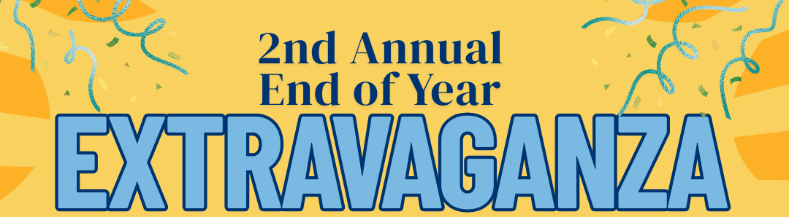

Friday, April 17th
11:00a - 2:00p
Oscar Ritchie Hall Rm 219
Once again, we are bringing the Kent State community together to celebrate the great work you've done. Join us for the 2025-2026 Teaching Scholars research presentations, THE GREAT KENT STATE TEACH-OFF finals, and recognition of CTL program participants. All are welcome to join in this celebration that will include light snacks and enjoyable conversation.

Click Here to Register for End of Year Extravaganza

~ Other Opportunities ~

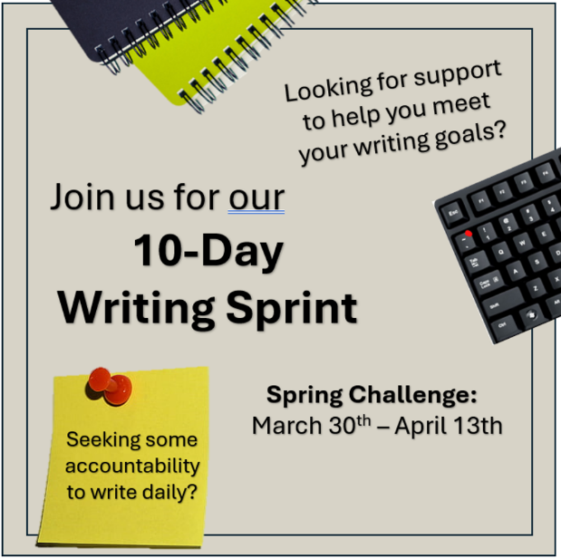

Click here for more information on the Writing Sprint and Self-Enroll

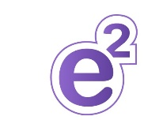

Save the date
This year's virtual conference will be on
Friday, February 27th, 2026
"Human-Centered Education: Accessibility, AI, and Innovative Instruction"
Join instructors, researchers, and technology leaders in elevating education that places human flourishing at its core. This conference explores (1) reimagining teaching through creativity, evidence-based practices and intentional design, (2) empowering instructors to responsibly use AI in ways that enhance – not replace – human connection and learning, and (3) centering access as a foundational element of human-centered education. Our hope is you will come away with new perspectives, connections with others and practical strategies.

Click here Submit a Proposal for the E2 Conference

Click here to Register for the E2 Conference

January Featured Educator

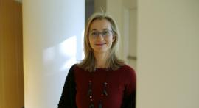

Yesim Kaptan
Associate Professor, Communication Studies, Kent Campus
Dr. Yesim Kaptan is being recognized for her impressive dedication to teaching development through extensive engagement with CTL events and programs as well as her commitment to bringing evidence-based strategies, purpose and relevance into her classroom. Most recently, as a Teaching Scholar, she enriched our faculty learning community and lead a research study about AI-designed activities.
Click here to view past featured educators or nominate a featured educator

Teaching Recognition Awards

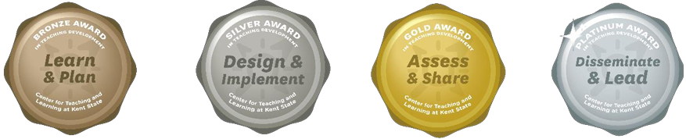

The Teaching Recognition Awards Program recognizes actions that enhance teaching and learning at Kent State University. Read more....
Congratulations to the Instructors Who Recently Received Awards:
Bronze Award Recipients
Jennifer Visker
Platinum Award Recipient
Samantha Bonaduce

Click Here to Learn More About TRAs and Apply Yourself

Connect with Us:

CTL is here to support you; whether it is teaching face-to-face, remote, or a combination of both. Email ctl@kent.edu with your questions and/or set up a consultation time.

ctl@kent.edu
http://www.kent.edu/ctl







This email was sent by: %%Member_Busname%%
The Center for Teaching and Learning, Cartwright Hall,
650 Hilltop Drive, Suite 220A, Kent, OH 44240

