

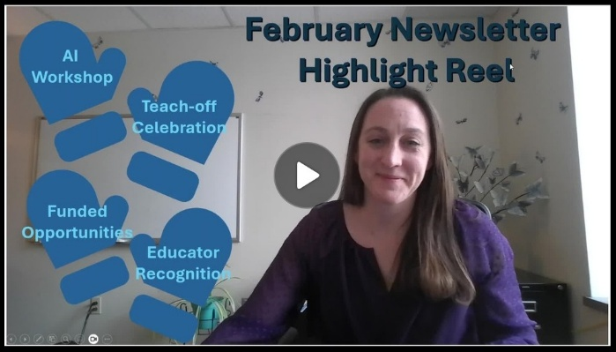

CTL Spring Semester Workshops

  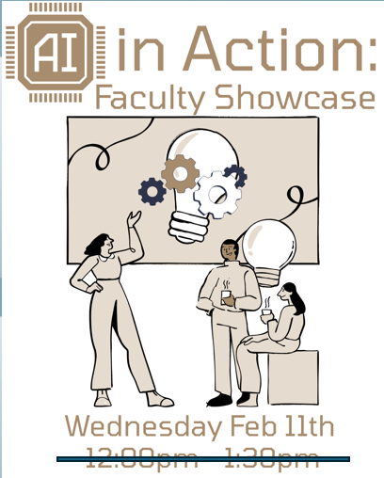
  AI in Action:
  Faculty Showcase
  Wednesday, February 11th
  Time Changed to 11:30a - 1:00p
  Microsoft Teams
  Curious how AI can truly support student learning? Join us as faculty share examples of how they’ve integrated AI into their courses to save time, spark student creativity, deepen engagement and enhance critical thinking.

Click here to register for AI in Action: Faculty Showcase

  
  The Great Kent State Teach-Off
  is Back!
  The Great Kent State Teach-Off is a friendly competition where instructors present for 5 minutes on something they do in their courses, such as an activity, technology, tool, assessment, etc. Each instructor will have 5 minutes to share what it is, how it works, and hints on how others can use it. This year we be hosting a single bracket of 10, so sign up soon if you are interested in competing.
  Learn more about the Teach-Off...
  Click Here to Compete
  Click Here to Attend and Judge

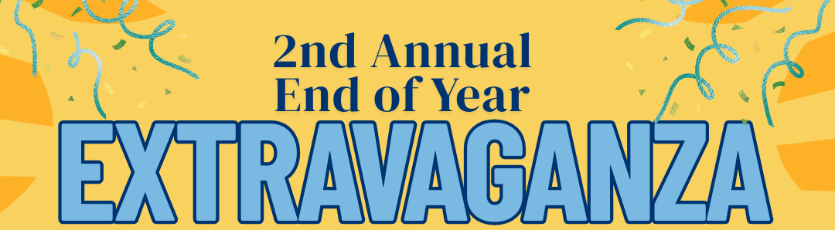

Friday, April 17th
11:00a - 2:00p
Oscar Ritchie Hall Rm 219
Once again, we are bringing the Kent State community together to celebrate the great work you've done. Join us for the 2025-2026 Teaching Scholars research presentations, THE GREAT KENT STATE TEACH-OFF finals, and recognition of CTL program participants. All are welcome to join in this celebration that will include light snacks and enjoyable conversation.

Click Here to Register for End of Year Extravaganza

2026 Teaching Scholars Program

  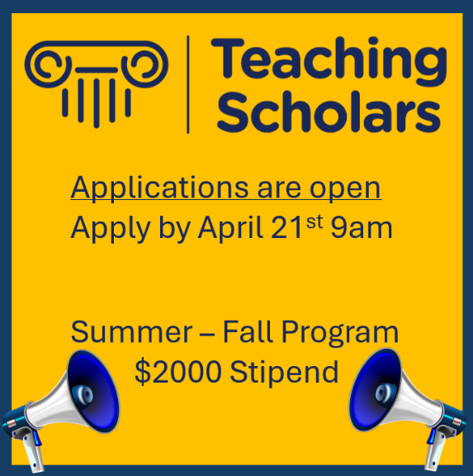
  The Teaching Scholars Program promotes shared scholarly inquiry into teaching and learning through relationships with interdisciplinary faculty while designing and implementing a scholarly examination of strategies that enhance student learning. Participants receive a $2000 stipend. Click here to learn more and view the tentative meeting schedule. Learn more....
  Click Here to Apply by April 21st

Additional Opportunities
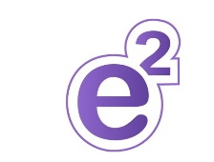

Friday, February 27th, 2026
"Human-Centered Education: Accessibility, AI, and Innovative Instruction"
Join instructors, researchers, and technology leaders in elevating education that places human flourishing at its core. This conference explores (1) reimagining teaching through creativity, evidence-based practices and intentional design, (2) empowering instructors to responsibly use AI in ways that enhance – not replace – human connection and learning, and (3) centering access as a foundational element of human-centered education. Our hope is you will come away with new perspectives, connections with others and practical strategies.
The schedule is packed with over two dozen sessions for you to check out. Register today!

Click Here to View Conference Schedule

Click here to Register for the E2 Conference

  
  The University Teaching Council's Summer Teaching Development Grant Application Open
  $9,000 10 Week Project
  $4,500 5 Week Project
  These grants are intended to enhance student learning by engaging faculty to significantly improve teaching methods, develop curricula, or create innovative
  course materials. Read more..
  Click here to apply for 2026 STDG

February Featured Educator



Samantha Bonaduce, DNP, RN, CNE
Associate Professor, Nursing
Tuscarawas Campus
Dr. Samantha Bonaduce is an educator whose excellence in the nursing classroom is helping her students learn problem- solving skills through branching scenarios and virtual escape rooms. These learning games are built through google forms that give students the virtual opportunity to critically think and learn while "playing." She has been recognized for her dedication to student learning, innovation in teaching and excellence in nursing education with the 2025 Elsevier Educator of the Year Award from the Organization for Associate Degree Nursing (OADN). Congratulations Dr. Bonaduce!
Click here to view past featured educators or nominate a featured educator

Teaching Recognition Awards

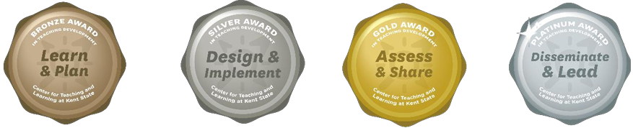

The Teaching Recognition Awards Program recognizes actions that enhance teaching and learning at Kent State University. Read more....
Congratulations to the Instructors Who Recently Received Awards
Bronze Award Recipients
Nicholas Ostrum

Click Here to Learn More About TRAs and Apply Yourself

Connect with Us:

CTL is here to support you; whether it is teaching face-to-face, remote, or a combination of both. Email ctl@kent.edu with your questions and/or set up a consultation time.

ctl@kent.edu
http://www.kent.edu/ctl

