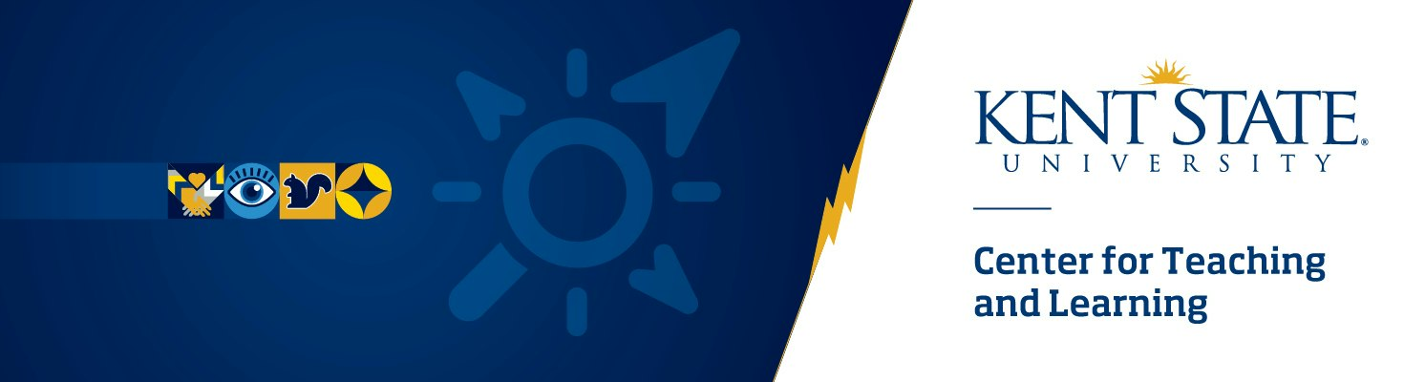

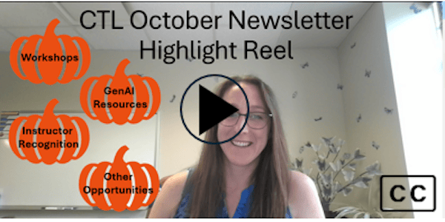
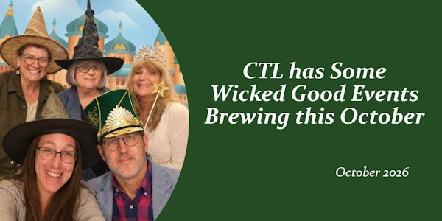

  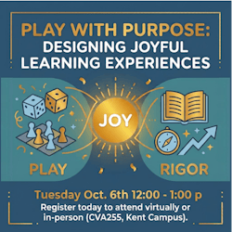
  Play with Purpose: Designing Joyful Learning Experiences
  Tuesday, October 6th 12:00p - 1:00p
  Hybrid Workshop In Person CVA255 or Microsoft Teams
  Emotion can affect whether a student tunes in or out, learns or doesn’t. By designing with the science of emotion in mind, we can influence students’ learning experiences. In this interactive hybrid workshop, you’ll discover how experiencing positive emotions in learning can increase student engagement, encourage collaboration, and support deeper learning without sacrificing rigor. These strategies will range from those requiring minimal planning to those that center around more extensive design that you can use in face-to-face or online courses. We will also offer guidance for lightening the design load, including use of GenAI.
  Click here to register for Play with Purpose: Designing Joyful Learning Experiences

  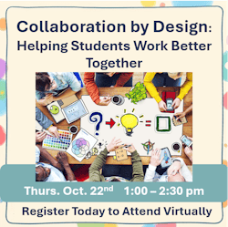
  Collaboration by Design: Helping Students Work Better Together
  Thursday, October 22nd 1:00p - 2:30p
  Microsoft Teams
  Students bring diverse experiences, expectations and comfort levels to collaborative learning. While teamwork remains one of the most sought-after skills by employers, effective collaboration doesn’t happen automatically. We can help our students to identify their own and others’ strengths and to work together productively. In this workshop, we will discuss practical approaches for preparing students for productive teamwork, creating structures that support collaboration.
  Click here to register for Collaboration by Design

  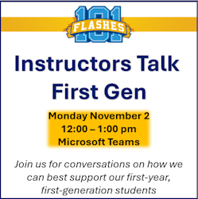
  Flashes 101 Instructors Talk
  First Gen
  Monday, November 2nd 12:00p - 1:00p
  Microsoft Teams
  In this interactive workshop, we will begin by looking at a snapshot of data related to First Generation students, particularly those who are first semester students in our Flashes 101 courses. We will then invite Flashes 101 instructors and all other interested attendees to join in conversation related to how we can best support our first year, first gen students. We encourage attendees to “pack a lunch” for our virtual gathering, if they wish to do so.
  Click here to register for Flashes 101 Instructors Talk First Gen

  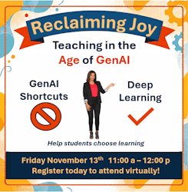
  Reclaiming Joy: Teaching in the Age of GenAI
  Friday, November 13th 11:00a - 12:00p
  Microsoft Teams
  Does worrying about students offloading their learning to GenAI steal your joy? We’ll explore ways to shift students’ focus away from grades and products by creating learning experiences that emphasize process, reflection, and authentic engagement. We will discuss the susceptibility of your assignments to GenAI use and provide suggestions for assignment design with and without incorporating GenAI into the assignment.
  Click here to register for Reclaiming Joy: Teaching in the Age of GenAI

  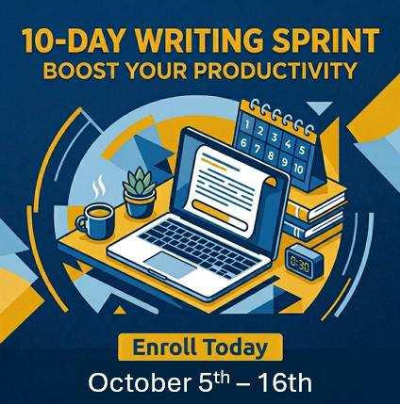
  10-Day Writing Sprint
  The 10-Day Writing Sprint is designed to help faculty jump-start their writing productivity through consistent writing, goal setting and accountability. Participants will make measurable progress on manuscripts, grant proposals, articles and other scholarly projects while developing sustainable writing habits, reducing procrastination and overcoming perfectionism.
  Click here to self-enroll in the Writing Sprint

  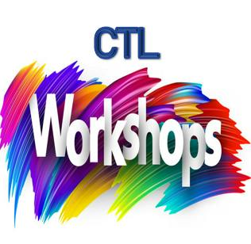
  CTL Spring Workshops
  Separating Fact from Fiction: Supporting Information Literacy
  Tuesday, February 2nd 12:00p - 1:00p
  Flexible Thinking by Design: Supporting Students in Developing a Thinking Skills Toolkit
  Friday, February 19th 11:00a - 1:00p
  Writing to Learn: Embracing Low-Stakes Writing in Any Discipline
  Wednesday, March 10th 9:15a - 10:30a
  The Lion, the Scarecrow, and the Tinman: Designing Courses that Develop Courage, Intellect, and Heart
  Monday, April 5th 12:00p - 1:15p
  All workshops via Microsoft Teams. Click on the workshop title above to view more information and register.

  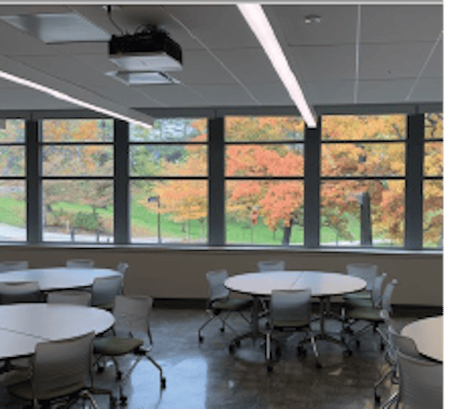
  Reserve CVA255 for Spring 2027
  Center for the Visual Arts (CVA) room 255 accommodates 30-35 students, naturally encourages group work and active-learning with movable tables and chairs. In addition to the two double-sided moveable whiteboards in the room, the walls are covered in magnetic whiteboards.
  Click here to learn more about and request CVA255

  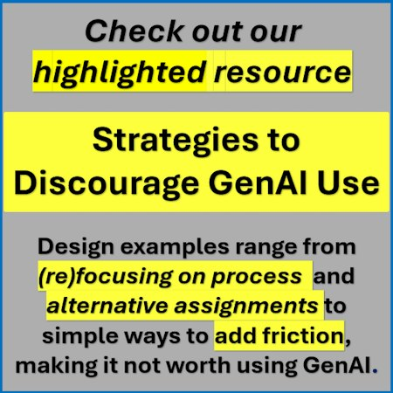
  Strategies to Discourage GenAI Use
  What can you do when student use of GenAI does not align with your learning objectives? We've organized strategies ranging from quick education and small changes to more intensive redesign examples. Check them out today by clicking on the link below:
  https://www.kent.edu/ctl/strategies-discourage-gai-use

  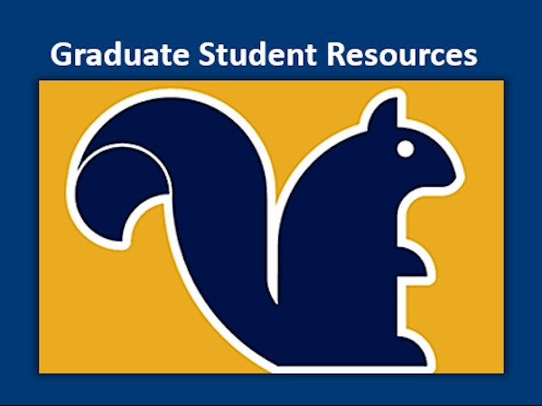
  Graduate Student Resources
  Are you a graduate student at Kent State? Do you know a graduate student who would appreciate opportunities to learn more about teaching and learning? Whether or not you're teaching right now, the CTL has resources for you, featuring a Canvas course with badges (micro credentials) on foundational teaching topics.
  Click here for resources related to Graduate Student Teaching or feel free to reach out to Adam Smith, Ph.D., Professional Development Specialist with Center for Teaching and Learning and University Colleges at asmit615@kent.edu.

  
  October Featured Educator
  Kelly Knapp-Blay, Associate Lecturer
  Marketing & Entrepreneurship
  Kent Campus
  Professor Kelly Knapp-Blay is being recognized for her commitment to student success both inside and outside the classroom. Kelly spent 25 years in the telecommunications industry and retired as the Vice President and General Manager for Ohio for Centurylink. Kelly now enjoys her “encore career” at Kent State University in the Ambassador Crawford College of Business and Entrepreneurship, where she leads the Sales Certificate program and prepares students in the Sales Organization and Pi Sigma Epsilon to compete in collegiate sales competitions. She travels with students, coaches them, and encourages them throughout the competitive process. Read more about Kelly...
  Submit Your Nomination Here for a colleague or yourself today!

  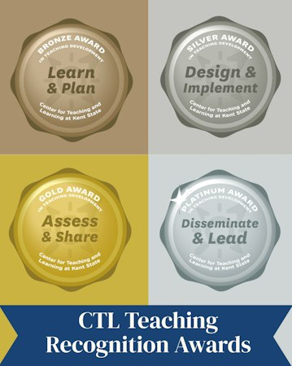
  The Teaching Recognition Awards Program recognizes actions that enhance teaching and learning at Kent State University.
  The objective of the teaching development awards program is to recognize actions that enhance teaching and learning at Kent State University. The program allows instructors to earn tiered awards (bronze, silver, gold & platinum) for their efforts to learn about, implement, evaluate and investigate evidence-based instructional practices. All instructors at Kent State, including graduate students and faculty of all appointment types (TT, NTT, adjunct) are eligible to participate.
  Congratulations to Teaching Recognition Award Recipients:
  Yesim Kaptan - Gold Awardee
  Karen Gracy - Bronze Awardee
  Click here to learn more about the TRA Program and participate

  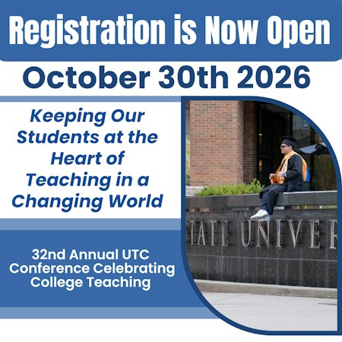
  Join Us for the 32nd Annual UTC Conference Celebrating College Teaching
  "Keeping Our Students at the Heart of Teaching in a
  Changing World"
  Friday, October 30, 2026
  8:30a - 4:00p
  KSC Ballroom
  View More Information and Register by clicking here


  

Join a Career Champions Training, led by Ellen Kratky and Dr. Justin Edwards, and discover how you can play a pivotal role in helping students align their academic journeys with their career aspirations.
Why Participate?
In today’s competitive academic and professional landscape, students need tailored guidance to make informed decisions about their majors and career goals. By becoming a Career Champion, you’ll gain the tools and knowledge to:
- Facilitate meaningful career conversations with students at any stage of their academic journey.
- Integrate career resources into your existing curriculum with students seamlessly.
- Connect students with specialized career advisors when deeper expertise is required.
What You’ll Gain:
- Engagement Techniques: Enhance your ability to guide students through career and major decision-making processes.
- Interactive Resources: Utilize tools like the Holland Code assessment and the FlashesGrow Guide to help students identify connections between their interests, academics, and career paths.
- Practical Experience: Work through real-world scenarios to build confidence in addressing a variety of student needs and goals.
- Exclusive Materials: Access the comprehensive Career Champions Toolkit, featuring worksheets, conversation guides, and continuous updates to support your work.
Event Details:
- Date: November 6th, 2026, 9:00-11:30am
- Location: Center for Undergraduate Excellence (CUE) Conference Room 143
- LearningStream Registration: https://reg.learningstream.com/reg/event_page.aspx?ek=0055-0003-f480b1a5587446a7b3084965d7fc6b0b
Contact: Ellen Kratky, Senior Career and Academic Advisor I, Career Exploration and Development (ecountry@kent.edu

Center for Teaching and Learning
250 Hilltop Dr./ Suite 220
330-672-2992
ctl@kent.edu

View Online | Unsubscribe

