

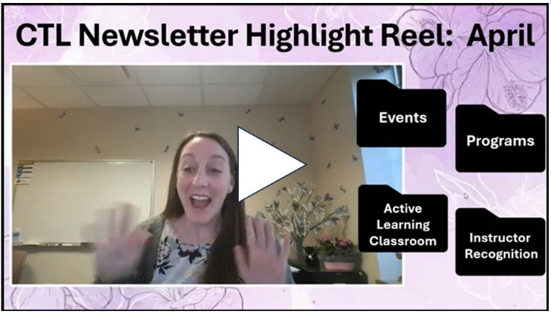

Spring Celebrations and Events

  
  We Need You!
  Voting Ends April 6th
  The Great Kent State Teach-Off
  is Back!
  This friendly competition features 5 faculty members (Kaatie Cooper, Sheren Farag, Chi-hua Groff, Jennifer Mapes and Ifran Mohammad) presenting for 5 minutes each on a strategy they use in their classes. View and vote before April 6th to help us choose who goes to the championship.

Click Here to View and Judge in the Great Kent State Teach-Off 's Preliminary Round



Friday, April 17th
11:00a - 1:00p
Oscar Ritchie Hall Rm 250
Once again, we are bringing the Kent State community together to celebrate the great work you've done. Join us for the 2025-2026 Teaching Scholars research presentations, THE GREAT KENT STATE TEACH-OFF finals, and recognition of CTL program participants. All are welcome to join in this celebration that will include light snacks and enjoyable conversation.

Click Here to Register for End of Year Extravaganza

2026 Programs Starting This Summer
Stipends Provided

  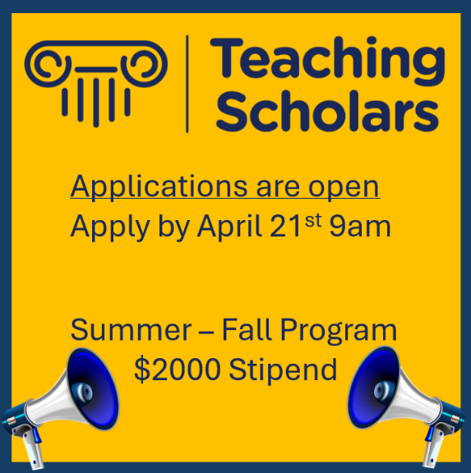
  The Teaching Scholars Program promotes shared scholarly inquiry into teaching and learning through relationships with interdisciplinary faculty while designing and implementing a scholarly examination of strategies that enhance student learning. Participants receive a $2000 stipend. Click here to learn more and view the tentative meeting schedule.
  Click Here to Apply by April 21st

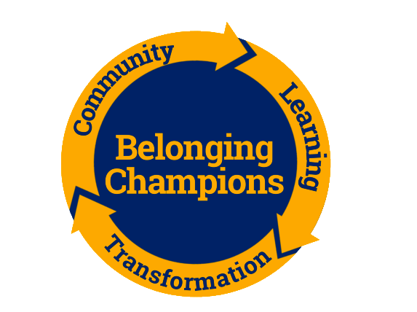
2026 Fall Belonging Champions Communities of Transformation
Application will Remain Open Until Cohorts are Filled
The program seeks to build relationships between faculty members and explore student success from the dimension of key conditions for thriving, such as belonging.
- $1,000.00 Stipend
- Weekly Virtual Meetings
Learn about and apply easy lift, high impact, evidence-based practices to improve student success. Click here to learn more...

Click Here to Apply for Fall Belonging Champions Program

Additional Opportunities

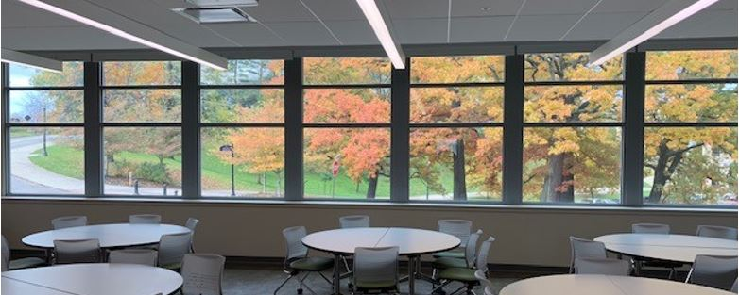

There is Still Time
Reserve CTL's Active Learning Classroom for Fall Semester
If you are looking for flexible space that promotes active learning, Center for Visual Arts (CVA) Room 255 may just be the space for your class.
Submit your request today!!

Click here to learn more about CVA255 and submit your request

  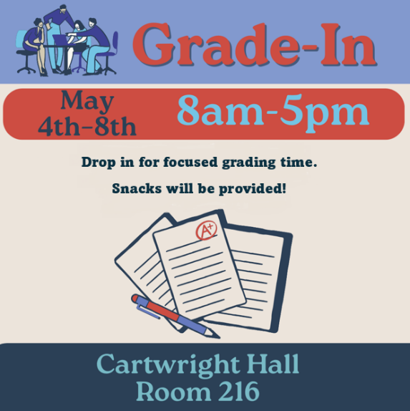
  Grading is Better Together
  Set aside distractions and grade alongside your peers in a supportive environment. Transform grading from a solitary task into a shared, productive experience. Bring your laptop, assignments and exams and join colleagues for a focused grading time, light refreshments, and access to
  fun breaks.
  Please let us know if you plan to attend the Grade-In by clicking here.

April Featured Educator

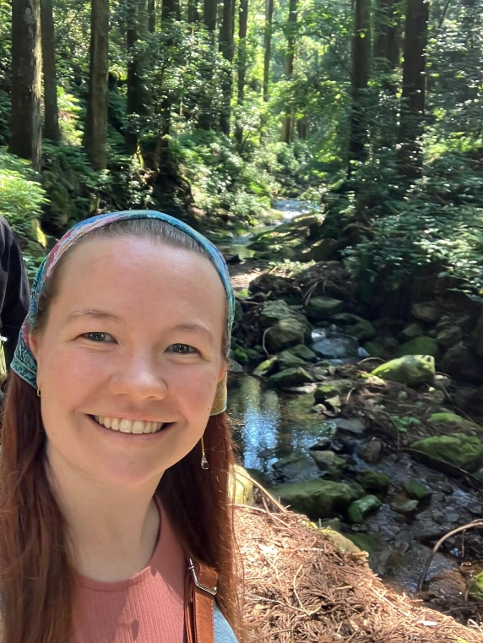
Caroline Spence
Graduate Student Instructor
English as a Second Language
Kent Campus
Caroline is being recognized for their commitment to ongoing professional development in teaching. Caroline is committed to providing a supportive environment for international students that recognizes their cultural differences and learning challenges they may experience in an unfamiliar educational environment.
Click here to view past featured educators or nominate a featured educator

Teaching Recognition Awards

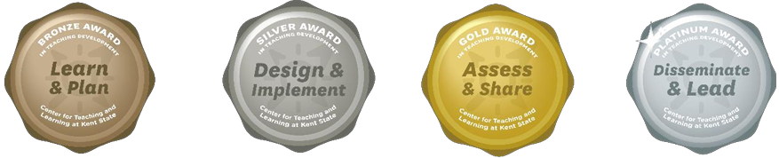

The Teaching Recognition Awards Program recognizes actions that enhance teaching and learning at Kent State University. Read more....
Congratulations to the Instructors Who Recently Received Awards
Bronze Award Recipients
Caroline Spence
Runxiang Jin
Platinum Award Recipients
Deepshikha Bhati

Click Here to Learn More About TRAs and Apply Yourself

Connect with Us:

CTL is here to support you; whether it is teaching face-to-face, remote, or a combination of both. Email ctl@kent.edu with your questions and/or set up a consultation time.

ctl@kent.edu
http://www.kent.edu/ctl







