

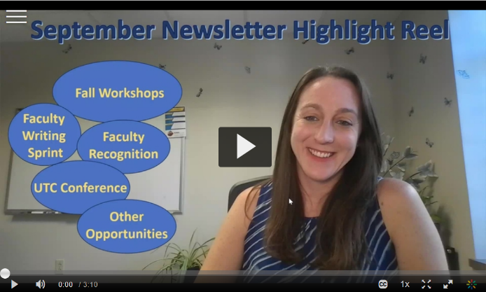


What's Happening This Fall

Teaching Through Transition: Practical Strategies to Navigate Legislative Changes
Many instructors have questions about how teaching may change given new legislation (SB1). We will be offering tangible strategies for navigating new legislation as it applies to teaching. Please join us for this virtual webinar. Please note: you must register using your Kent State credentials. A Teams link will be provided shortly before the webinar begins.
Join us virtually for one of remaining offerings:
September 11th - 3:00p - 4:30p
September 15th - 6:00p - 7:30p

Click here to register for September 11th Teaching Through Transition

Click here to register for September 15th Teaching Through Transition

  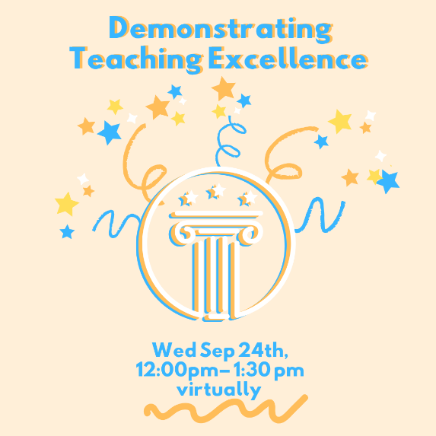
  Demonstrating Teaching Excellence
  Wednesday, September 24th
  12:00p - 1:30p
  Virtual Workshop
  This interactive workshop helps you identify, document, and present what makes your teaching distinctive and effective. You will come away with strategies to translate daily classroom successes and ways of gaining more evidence to support your teaching excellence.

Click here to register for Demonstrating Teaching Excellence

  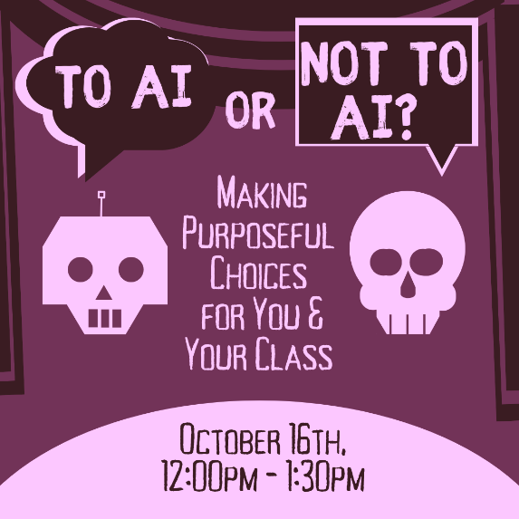
  To AI or Not To AI: Making Purposeful Choices for You & Your Class
  Thursday, October 16th
  12:00pm to 1:30pm
  Virtual Workshop
  AI can save time and open doors to new ways of thinking and doing, but when should we use it and when should we turn away? This workshop guides you through intentional decision-making and evaluating AI options, while reflecting on challenges and considering learning outcomes

Click here to register for To AI or Not to AI

  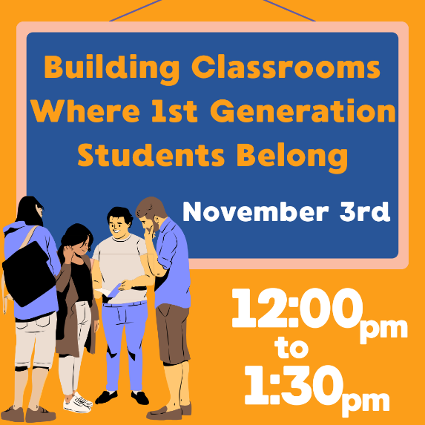
  Building Classrooms Where First-Generation Students Belong
  Monday, November 3rd
  12:00pm - 1:30pm
  Virtual Workshop
  Creating communities in our classroom for all students starts with thinking about what first generation students need to know to succeed. This workshop will focus on how to destigmatize resource sharing and self-efficacy for help seeking, while offering strategies for belonging and community building for everyone that will emphasize thriving and belonging.

Click here to register for Building Classrooms Where First-Gen Students Belong

  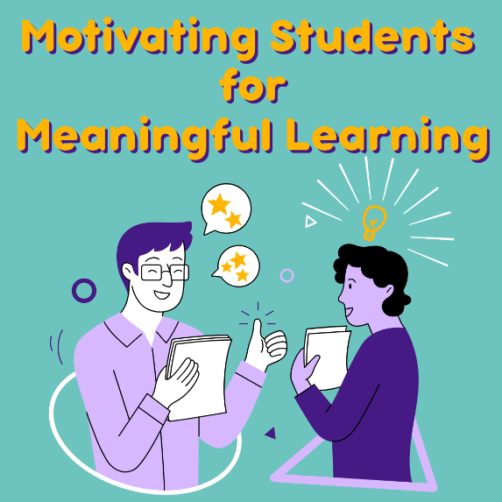
  Motivating Students for Meaningful Learning
  Wednesday, November 12th
  12:00pm - 1:30pm
  Virtual Workshop
  Wanting to move past grades-as-carrots and into learning as its own reward? This workshop will unpack research on motivation and discuss practical strategies that invite students to own their learning journey and build classroom environments where motivation thrives.

Click here to register for Motivating Students for Meaningful Learning

~ Other Opportunities ~

  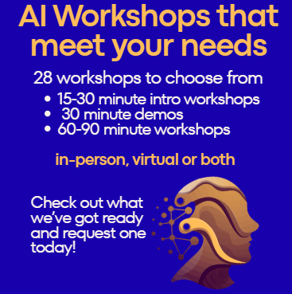
  AI Workshops
  The CTL offers a variety of workshops related to AI. All workshops can be held in-person or virtually. You can request any of these workshops by emailing ctl@kent.edu or clicking here.
  All of these workshops count towards the AI-Ready Educator Recognition.

  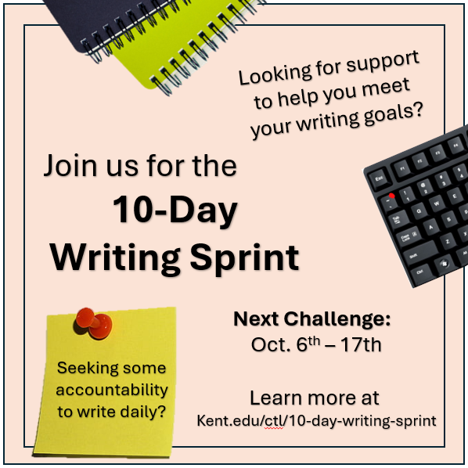
  10-Day Writing
  Sprints Continue
  this Fall
  Write wherever and whenever you want with asynchronous connections and accountability. Learn more...

Click here to self-enroll in the 10-Day Fall Writing Sprint

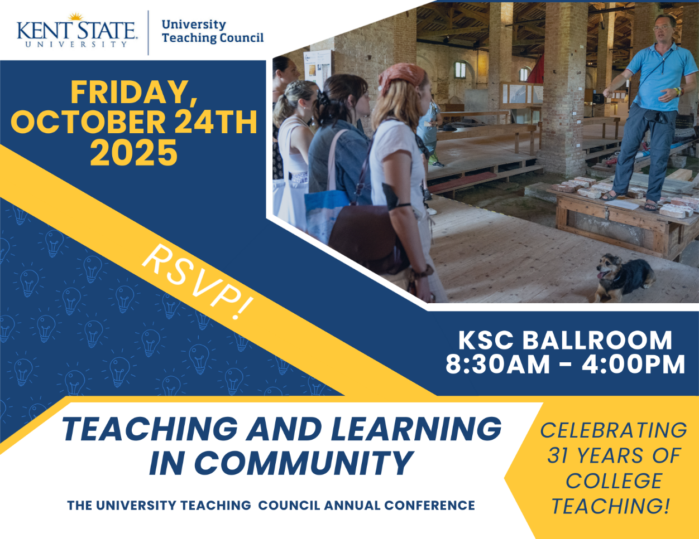

Click here to view the UTC Conference Sharepoint Site

Click here to register for UTC Conference on College Teaching

September Featured Educator

  
  Melissa Higgins-Linder,
  Associate Lecturer,
  Art Education, Kent Campus
  Missy Higgins-Linder, an alum of KSU Art Education (BA; MA) is extensive in accommodating students in her Art Education courses, showing all who are in the span of her care that their growth is the priority. Read more...

~ Teaching Recognition Awards ~

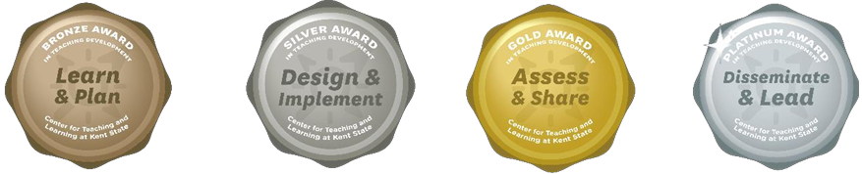

The Teaching Recognition Awards Program recognizes actions that enhance teaching and learning at Kent State University. Read more....
Congratulations to the Instructors Who Recently Received Awards
Bronze Award Recipients
Joseph Bedont
Elaheh Sabziyan Varnousfaderani

Click Here to Learn More About TRAs and Apply Yourself

Did You Know??

The Early Alert System is Moving to KSU Navigate
The Early Alert system will be transitioning out of the current system and integrated into KSU Navigate, with a plan to go live on Monday, September 15th.
The Early Alert system is still designed for faculty and instructors to submit academic-related concerns on behalf of students who are enrolled in their courses.
The Early Alert Team will provide training for Success Navigators and Faculty to ensure they are fully prepared to navigate the new system. Additional details and training invitations will be shared by the Early Alert Team in the coming weeks.
If you have any questions, feel free to reach out to earlyalert@kent.edu

Workshop Alert from Institutional Effectiveness - Assessment:
From Evidence to Action – Showing Use of Assessment Results
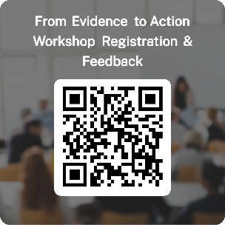
Looking for ways to make your program or course assessment results more actionable and meaningful?
Join us for the Fall 2025 “From Evidence to Action” Workshop, designed for faculty and assessment administrators who want to move beyond compliance and use data to drive real change.
What You’ll Gain:
- Tools to identify and implement strong actions based on assessment of student learning findings
- Guidance on documenting and communicating action plans
- Tips for closing the loop and engaging stakeholders
- Hands-on practice using Watermark PSS to track progress
Workshop Options:
- 💻 Virtual Session: September 25, 2025, 11:30-1:00 pm – via Microsoft Teams
- 🏫 In-Person Session: October 23, 2025, 12-2:00 pm (bring your lunch - and learn!) – University Library, Room 209A
RSVP Here: https://forms.office.com/r/tRCp06UCBu
Let’s work together to turn evidence into action and make assessment of student learning meaningful!
Questions? Contact Shannon Helfinstine at assessment@kent.edu

Connect with Us:

CTL is here to support you; whether it is teaching face-to-face, remote, or a combination of both. Email ctl@kent.edu with your questions and/or set up a consultation time.
http://www.kent.edu/ctl

