



What's Happening This Fall

  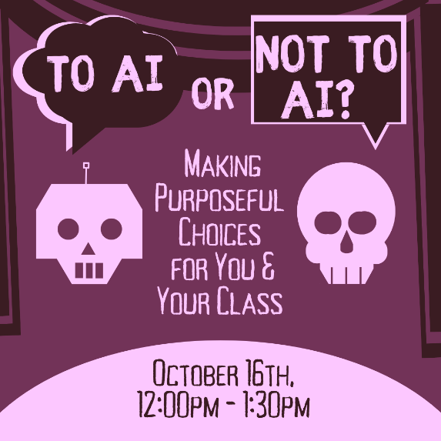
  To AI or Not To AI: Making Purposeful Choices for You &
  Your Class
  Thursday, October 16th
  12:00pm to 1:30pm
  Virtual Workshop
  AI can save time and open doors to new ways of thinking and doing, but when should we use it and when should we turn away? This workshop guides you through intentional decision-making and evaluating AI options, while reflecting on challenges and considering learning outcomes

Click here to register for To AI or Not to AI

  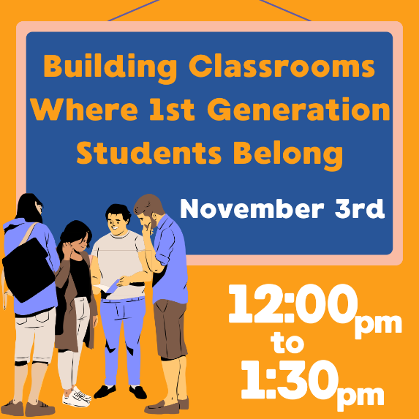
  Building Classrooms Where First-Generation Students Belong
  Monday, November 3rd
  12:00pm - 1:30pm
  Virtual Workshop
  Creating communities in our classroom for all students starts with thinking about what first generation students need to know to succeed. This workshop will focus on how to destigmatize resource sharing and self-efficacy for help seeking, while offering strategies for belonging and community building for everyone that will emphasize thriving and belonging.

Click here to register for Building Classrooms Where First-Gen Students Belong

  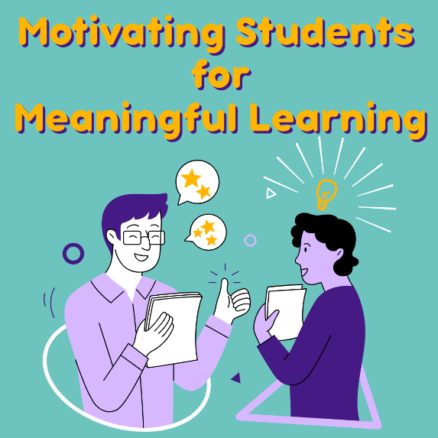
  Motivating Students for Meaningful Learning
  Wednesday, November 12th
  12:00pm - 1:30pm
  Virtual Workshop
  Wanting to move past grades-as-carrots and into learning as its own reward? This workshop will unpack research on motivation and discuss practical strategies that invite students to own their learning journey and build classroom environments where motivation thrives.

Click here to register for Motivating Students for Meaningful Learning

~ Other Opportunities ~

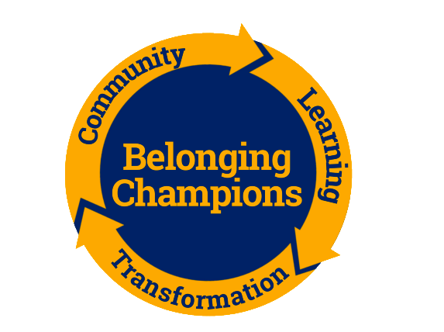

The Belonging Champions program is seeking faculty for Spring 2026 cohorts. Utilizing key learning conditions, such as Belonging Certainty and Self Efficacy, Champions will seek to build relationships with one another in communities of transformation. Participants apply easy-lift, high-impact, evidence-based practices, gather real-time student feedback on the key conditions for thriving, and explore the larger contexts in which this work occurs. Please visit our Belonging Champions website for additional program information. All Kent State instructors who are teaching at least one course during Spring 2026 are encouraged to apply. Current and former Champions who have already participated once may also apply to be a returning Champion (on a non-stipend appointment) and will be considered if there is space.
Register to be a Belonging Champion at this link. (Stipend $1,000)
If you are a former Belonging Champion and you are interested in facilitating a community in the spring, please apply here. (Stipend $1,500)
All applications are due on Monday, November 3.

  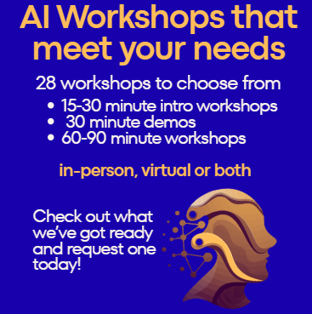
  AI Workshops
  The CTL offers a variety of workshops related to AI. All workshops can be held in-person or virtually. You can request any of these workshops by emailing ctl@kent.edu or clicking here.
  All of these workshops count towards the AI-Ready Educator Recognition.

  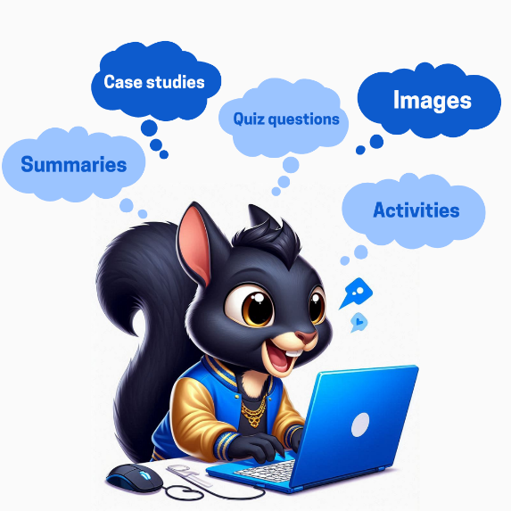
  Sharing Your Ideas About AI and Your Teaching
  At Kent State, many of you are pioneering ways to use AI. Whether you are developing an AI policy for your course/assignment, integrating AI into assignments, or streamlining instructor-related tasks – our KSU community can benefit from hearing about your great work. We also have some amazing researchers engaging in AI related to their teaching and/or student learning, and we’d love to highlight your work. We invite you to share your ideas/practices/research to further advance AI innovation at Kent State and connect with others.

Click here share your AI Ideas

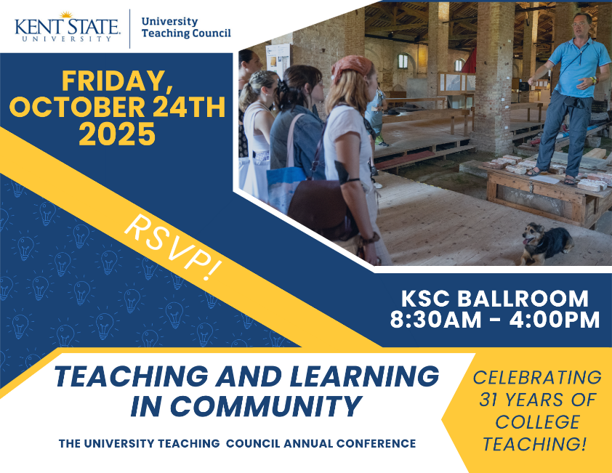

Click here to view the UTC Conference Sharepoint Site

Click here to register for UTC Conference on College Teaching

October Featured Educator

  
  Lauren Copeland, Ph.D.
  Associate Professor
  Fashion Design & Merchandising,
  Kent Campus
  Dr. Copeland has done a great deal of work within her Fundamentals class (required by all fashion students) to create a series of self-directed efficacy building activities to help students refine what they want to do in the fashion industry. Click here to read more...

~ Teaching Recognition Awards ~

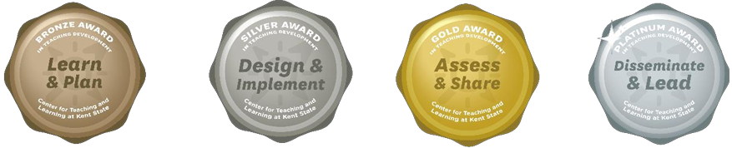

The Teaching Recognition Awards Program recognizes actions that enhance teaching and learning at Kent State University. Read more....
Congratulations to the Instructors Who Recently Received Awards
Bronze Award Recipients
Courtney Wagner
Platinum Award Recipients
Chia-Ling Kuo
Elena Novak

Click Here to Learn More About TRAs and Apply Yourself

Did You Know??

Step Up & Speak Out
Tuesday, October 28th, 2025, 3-4pm Via Teams
(training Teams link sent to registrants the day prior to the training date). Registration link is below.
Training Description: Step Up & Speak Out is a collaborative initiative designed to educate the university community on how to identify and assist individuals in destress or who are disruptive. It provides resources including a response guide, information on responding to suicide risk, and training for faculty and staff to foster a more caring campus culture by increasing awareness of mental health concerns and reducing stigma. Approved for 1 hour of Beyond Compliance credit.
Presenters include: Dr. Josh Perkins, Dean of Students, Dr. John Schell, Director, Counseling and Psychological Services, Ken Ditlevson, Director, CARES Center, and staff from the Kent State University Police Department.
To register: Register online at: https://www.kent.edu/people-and-culture/learning-development then click the “Register for Training” option and go to October 28th to select Step Up & Speak Out.

Connect with Us:

CTL is here to support you; whether it is teaching face-to-face, remote, or a combination of both. Email ctl@kent.edu with your questions and/or set up a consultation time.
ctl@kent.edu
http://www.kent.edu/ctl

