

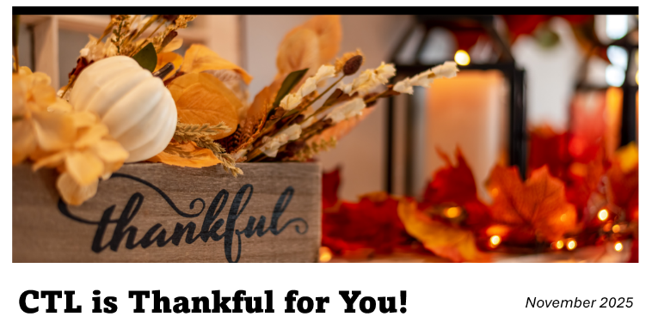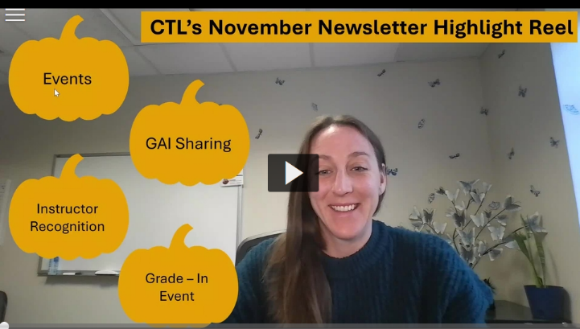

November Workshops

  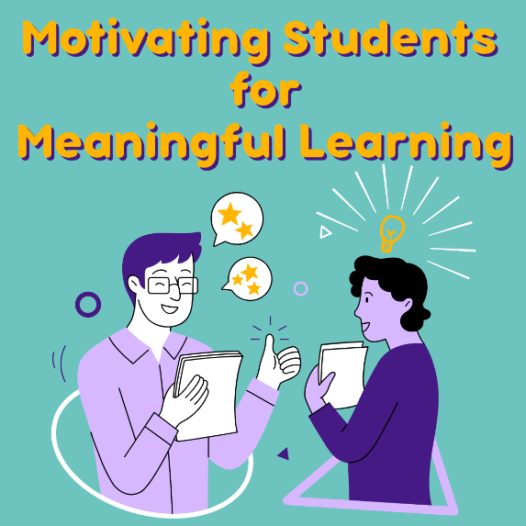
  Motivating Students for Meaningful Learning
  Wednesday, November 12th
  12:00pm - 1:30pm
  Virtual Workshop
  Wanting to move past grades-as-carrots and into learning as its own reward? This workshop will unpack research on motivation and discuss practical strategies that invite students to own their learning journey and build classroom environments where motivation thrives.

Click here to register for Motivating Students for Meaningful Learning

~ Other Opportunities ~

  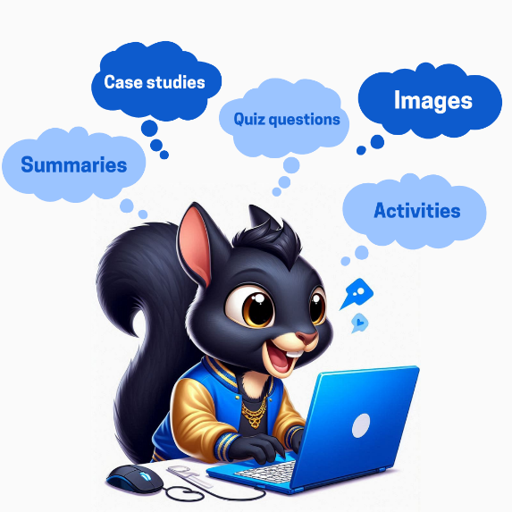
  Sharing Your Ideas About AI and Your Teaching
  At Kent State, many of you are pioneering ways to use AI. Whether you are developing an AI policy for your course/assignment, integrating AI into assignments, or streamlining instructor-related tasks – our KSU community can benefit from hearing about your great work. We also have some amazing researchers engaging in AI related to their teaching and/or student learning, and we’d love to highlight your work. We invite you to share your ideas/practices/research to further advance AI innovation at Kent State and connect with others.

Click here share your AI Ideas

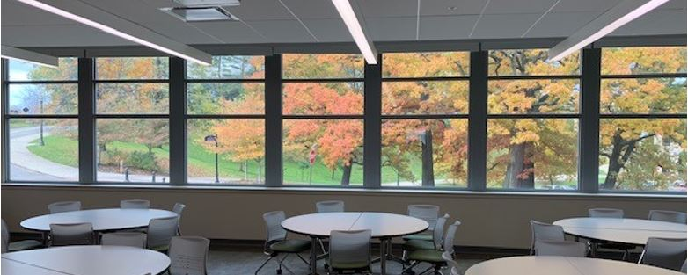

Reserve CVA255 for Spring 2026
Center for the Visual Arts (CVA) room 255 accommodates 30-35 students, naturally encourages group work and active-learning with movable tables and chairs and Chromebooks for each student. In addition to the two double-sided moveable whiteboards in the room, the walls are covered in magnetic whiteboards.

Click here to learn more and request CVA255

November Featured Educators

Congratulations to the 2025
Glenn Frank Distinguished Teaching Award
Recipients and Finalists

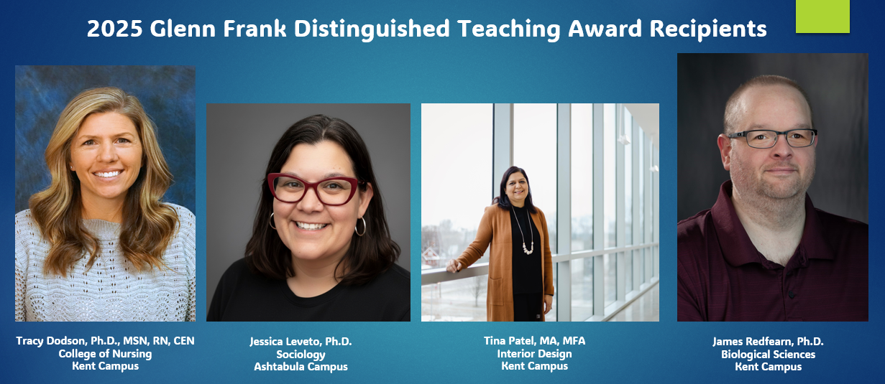

Congratulations to these outstanding finalists of this year’s
Glenn Frank Distinguished Teaching Award:
Hayley Arnold, Ph.D. Samantha Bonaduce, DNP, RN, CNE
Jean Engohang-Ndong, Ph.D. Matthew Holm, DMA
Susan Kunkle, Ph.D. James Winter, MFA

~ Teaching Recognition Awards ~

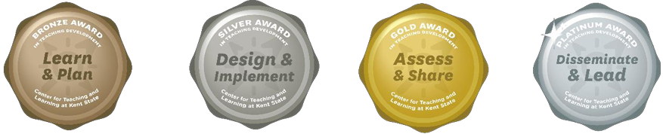

The Teaching Recognition Awards Program recognizes actions that enhance teaching and learning at Kent State University. Read more....
Bronze Award Recipients Silver Award Recipients Platinum Award Recipient
Reza Pedarpour X3 Martha Daniels Shahla Asadi
William Bolden III

Click Here to Learn More About TRAs and Apply Yourself

Did You Know??

  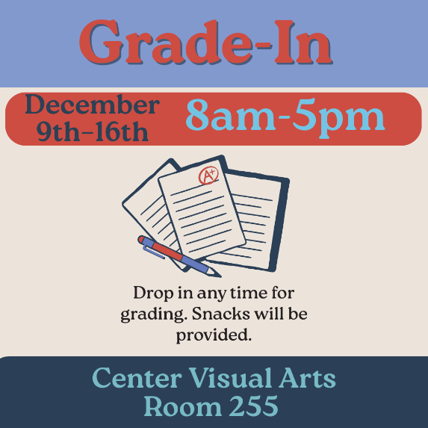
  Grading is Better Together
  Set aside distractions and grade alongside your peers in a supportive environment. Transform grading from a solitary task into a shared, productive experience. Bring your laptop, assignments and exams and join colleagues for a focused grading time, light refreshments, and access to fun breaks.

Connect with Us:

CTL is here to support you; whether it is teaching face-to-face, remote, or a combination of both. Email ctl@kent.edu with your questions and/or set up a consultation time.

ctl@kent.edu
http://www.kent.edu/ctl







