



New Opportunity this December

  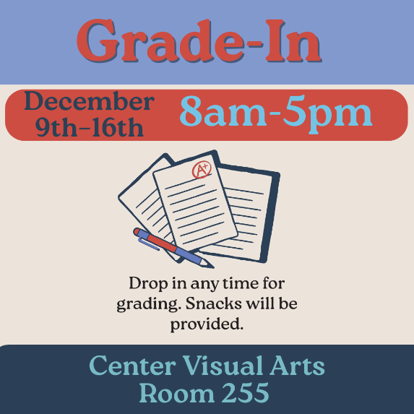
  Grading is Better Together
  Weekdays December 9th -16th
  8:00a - 5:00p
  Center for Visual Arts 255 (CVA255)
  Set aside distractions and grade alongside your peers in a supportive environment. Transform grading from a solitary task into a shared, productive experience. Bring your laptop, assignments and exams and join colleagues for a focused grading time, light refreshments, and access to fun breaks.

Click here to sign-up and let us know when you may be joining us

Spring Semester Workshops

  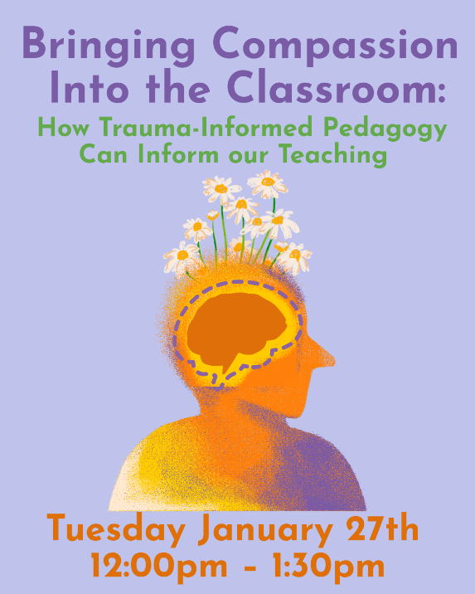
  Bringing Compassion into the Classroom: How Trauma-Informed Pedagogy Can Inform our Teaching
  Tuesday, January 17th
  12:00p - 1:30p
  Microsoft Teams
  This workshop will detail what trauma is, how it shows up in our classrooms, and how it affects students’ ability to learn.

Click here to register for Bringing Compassion to the Classroom

  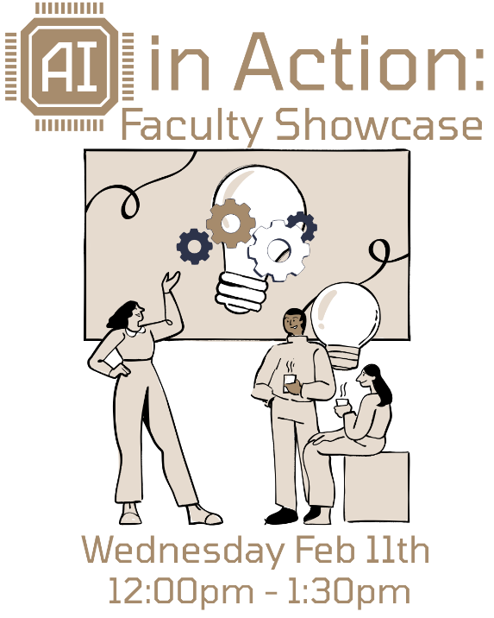
  AI in Action:
  Faculty Showcase
  Wednesday, February 11th
  12:00p - 1:30p
  Microsoft Teams
  Curious how AI can truly support student learning? Join us as faculty share examples of how they’ve integrated AI into their courses to save time, spark student creativity, deepen engagement and enhance critical thinking.

Click here to register for AI in Action: Faculty Showcase

  
  The Great Kent State Teach-Off
  is Back!
  The Great Kent State Teach-Off is a friendly competition where instructors present for 5 minutes on something they do in their courses, such as an activity, technology, tool, assessment, etc. Each instructor will have 5 minutes to share what it is, how it works, and hints on how others can use it. This year we are limiting the number of competitors to 10 and having one competition bracket with no edited videos.
  Stay tuned for more information on how you can watch the preliminaries scheduled for March 20th.
  Learn more about the Teach-Off..
  Click Here to Sign-Up and Compete

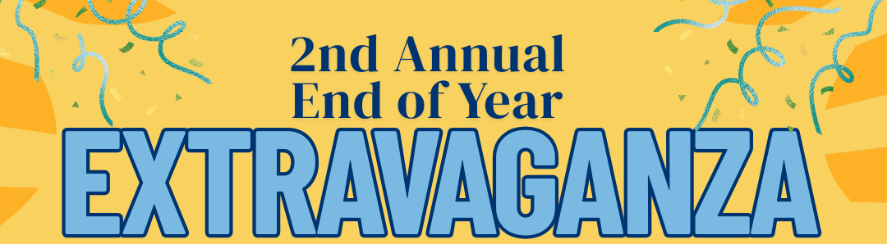

Save the Date
Friday, April 17th
11:00a - 2:00p
More Information Coming This Spring

~ Other Opportunities ~

  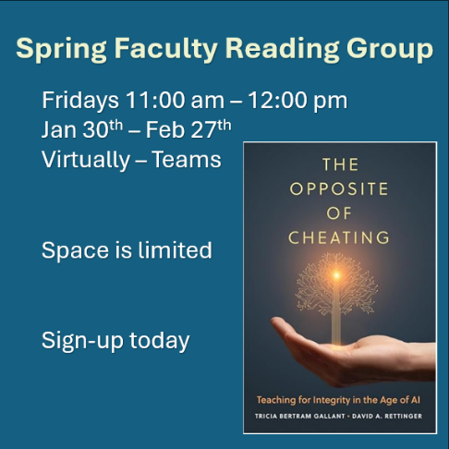
  Spring Faculty
  Reading Group
  The Opposite of Cheating
  Teaching for Integrity in the Age of AI
  The Opposite of Cheating presents a positive, forward-looking, research-backed vision for what classroom integrity can look like in the GenAI era, both online and on campus.
  Learn more...

Click here to sign-up for the Spring Faculty Reading Group

  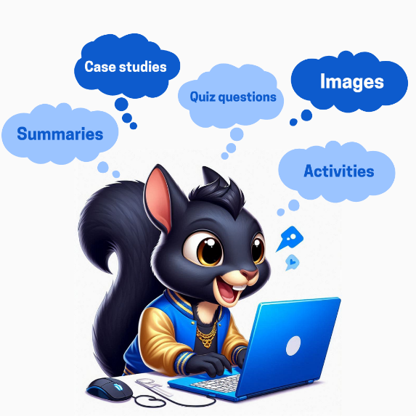
  Sharing Your Ideas About AI and Your Teaching
  At Kent State, many of you are pioneering ways to use AI. Whether you are developing an AI policy for your course/assignment, integrating AI into assignments, or streamlining instructor-related tasks – our KSU community can benefit from hearing about your great work. We also have some amazing researchers engaging in AI related to their teaching and/or student learning, and we’d love to highlight your work. We invite you to share your ideas/practices/research to further advance AI innovation at Kent State and connect with others.

Click here share your AI Ideas

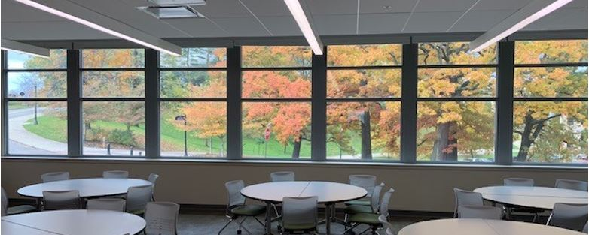

Reserve CVA255 for Spring 2026
Center for the Visual Arts (CVA) room 255 accommodates 30-35 students, naturally encourages group work and active-learning with movable tables and chairs and Chromebooks for each student. In addition to the two double-sided moveable whiteboards in the room, the walls are covered in magnetic whiteboards.

Click here to learn more and request CVA255

December Featured Educator



Reza Pedarpour Vajargah
Ph.D. Candidate
Department of Marketing & Entrepreneurship Kent Campus
Reza transforms his marketing courses into dynamic spaces where students connect theory to real-world decisions through data-driven and hands-on activities.
​​​​​​​Read more....

Teaching Recognition Awards

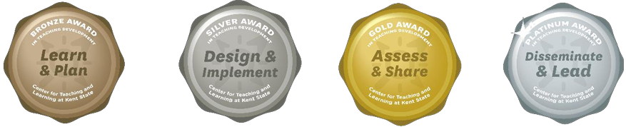

The Teaching Recognition Awards Program recognizes actions that enhance teaching and learning at Kent State University. Read more....
Congratulations to the Instructors Who Recently Received Awards
Bronze Award Recipients
William Bolden III
Gold Award Recipient
Sonya Irving

Click Here to Learn More About TRAs and Apply Yourself

Connect with Us:

CTL is here to support you; whether it is teaching face-to-face, remote, or a combination of both. Email ctl@kent.edu with your questions and/or set up a consultation time.

ctl@kent.edu
http://www.kent.edu/ctl







