



Welcome Back from Our Director

As we begin the Fall semester, I want to welcome each and every one of you. It is my sincere hope that your summer provided you with renewed energy for the year ahead. As I see students arriving back on campus, I am reminded of the vital role that you each play in creating welcoming and inspiring learning experiences. Please know how much I appreciate you and value the work that we do together.
Wishing you all the best for the year ahead~
Jenny

Congratulations!

  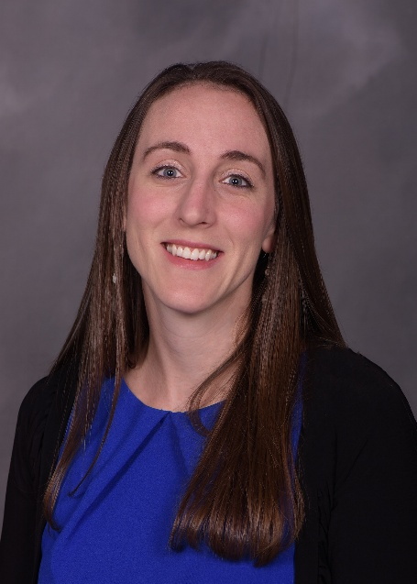
  ~
  Assistant Director, Innovative Teaching
  The Center for Teaching and Learning is pleased to announce that LeighAnn Tomaswick has been recognized for her outstanding contributions by being named the Assistant Director for Innovative Teaching. Please join us in congratulating her!
  ~

What's Happening This Fall

Teaching Through Transition: Practical Strategies to Navigate Legislative Changes
Click here to register for August 27 Teaching Through Transition
Many instructors have questions about how teaching may change given new legislation (SB1). We will be offering tangible strategies for navigating new legislation as it applies to teaching. Please join us for this virtual webinar. Please note: you must register using your Kent State credentials. A Teams link will be provided shortly before the webinar begins.
Join us virtually for one of the offerings:
August 27th - 12:00p - 1:30p
Click here to register for September 11th Teaching Through Transition
September 11th - 3:00p - 4:30p
Click here to register for September 15th Teaching Through Transition
September 15th - 6:00p - 7:30p

Demonstrating Teaching Excellence
Wednesday, September 24th
12:00p - 1:30p
Virtual Workshop
This interactive workshop helps you identify, document, and present what makes your teaching distinctive and effective. You will come away with strategies to translate daily classroom successes and ways of gaining more evidence to support your teaching excellence.

Click here to register for Demonstrating Teaching Excellence

To AI or Not To AI: Making Purposeful Choices for You & Your Class
Thursday, October 16th
12:00pm to 1:30pm
Virtual Workshop
AI can save time and open doors to new ways of thinking and doing, but when should we use it and when should we turn away? This workshop guides you through intentional decision-making and evaluating AI options, while reflecting on challenges and considering learning outcomes

Click here to register for To AI or Not to AI

Building Classrooms Where First-Generation Students Belong
Monday, November 3rd
12:00pm - 1:30pm
Virtual Workshop
Creating communities in our classroom for all students starts with thinking about what first generation students need to know to succeed. This workshop will focus on how to destigmatize resource sharing and self-efficacy for help seeking, while offering strategies for belonging and community building for everyone that will emphasize thriving and belonging.

Click here to register for Building Classrooms Where First-Gen Students Belong

Motivating Students for Meaningful Learning
Wednesday, November 12th
12:00pm - 1:30pm
Virtual Workshop
Wanting to move past grades-as-carrots and into learning as its own reward? This workshop will unpack research on motivation and discuss practical strategies that invite students to own their learning journey and build classroom environments where motivation thrives.

Click here to register for Motivating Students for Meaningful Learning

~ Other Opportunities ~

  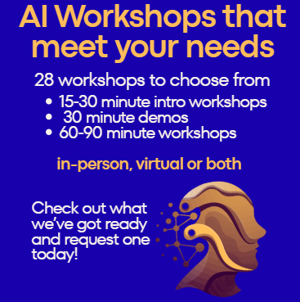
  AI Workshops
  The CTL offers a variety of workshops related to AI. All workshops can be held in-person or virtually. You can request any of these workshops by emailing ctl@kent.edu or clicking here.
  All of these workshops count towards the AI-Ready Educator Recognition.

  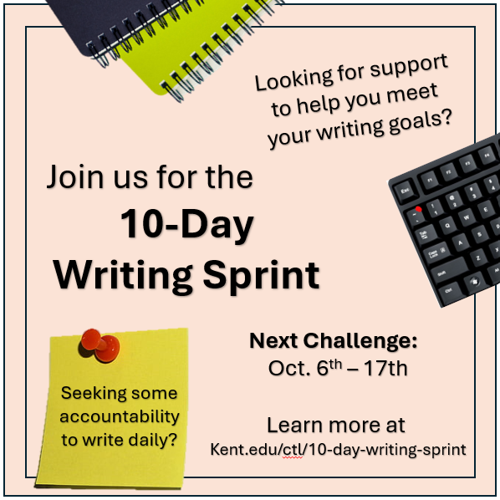
  10-Day Writing
  Sprints Continue
  this Fall
  The 10-Day Writing Sprint is designed to help faculty jumpstart their writing productivity by fostering consistency, focus, and momentum. Through structured daily writing sessions, goal setting, and accountability, participants will make measurable progress on their writing projects—whether it’s a manuscript, grant proposal, article, or other scholarly work. Learn more...

Click here to self-enroll in the 10-Day Fall Writing Sprint

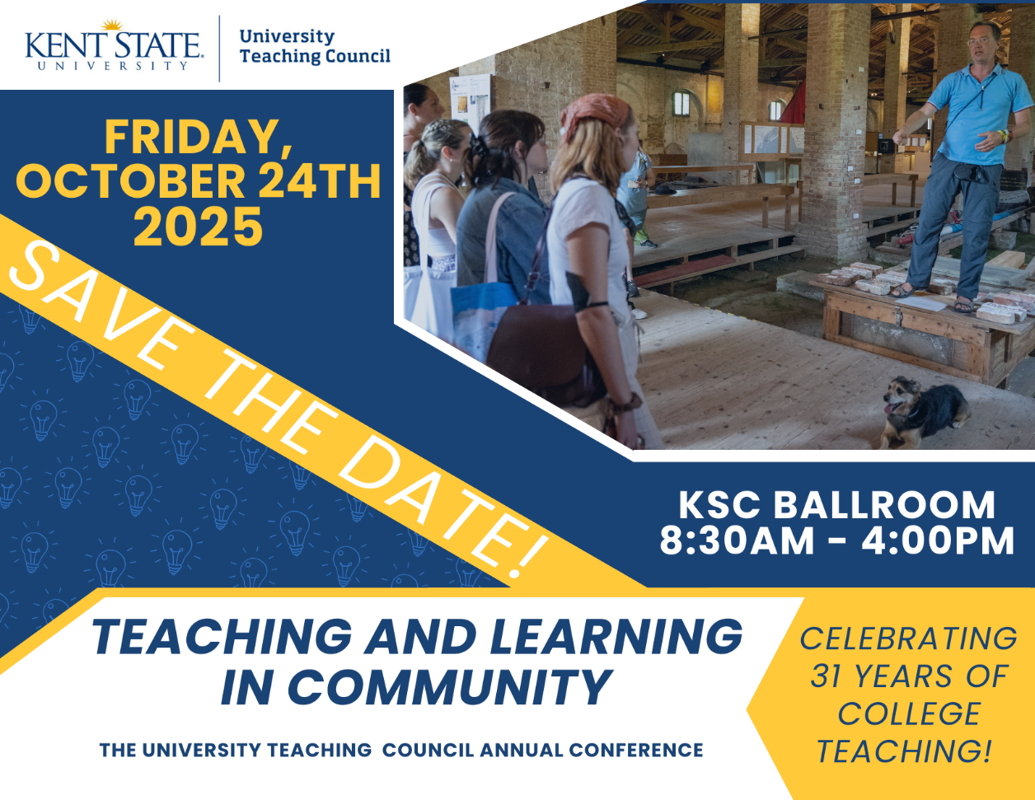

Click here to register for UTC Conference on College Teaching

Featured Educators
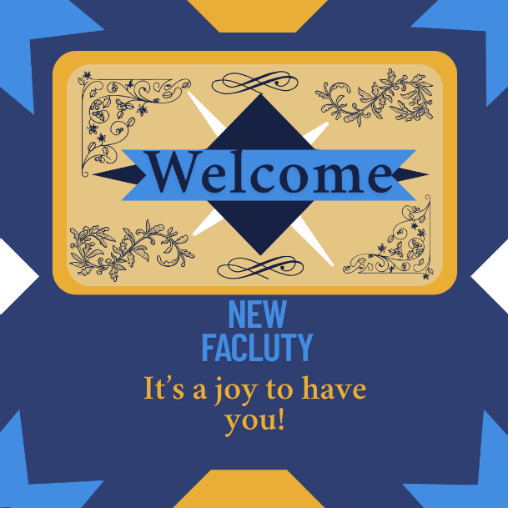

~ Teaching Recognition Awards ~

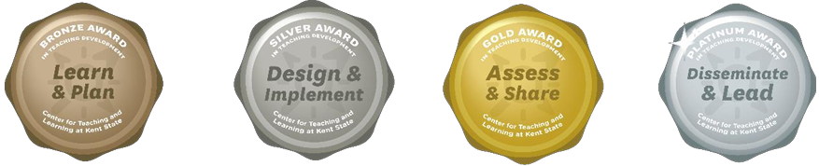

The Teaching Recognition Awards Program recognizes actions that enhance teaching and learning at Kent State University. Read more....
Congratulations to the Instructors Who Received Awards Over the Summer:
Bronze Award Recipients
Kimberly Klaskin
Alindomar Lacerda Silva
Patwary MD Masum Ikbal
Elaheh Sabziyan Varnousfaderani - 3 Awards
Karen Wetzel
Silver Award Recipients
Brandi Nelson - 3 Awards
Ning-Kuang Chuang
Patwary MD Masum Ikbal - 2 Awards
Gold Award Recipients
Erin Hollenbaugh

Click Here to Learn More About TRAs and Apply Yourself

Did You Know??

Kent State has organizations and clubs that support student belonging. The links below will provide information for each of the eight Kent campuses.

  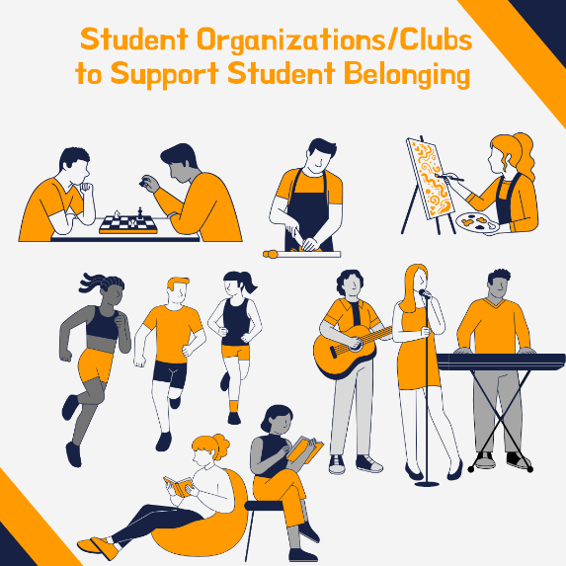
  Ashtabula Campus: https://www.kent.edu/ashtabula/student-life
  Geauga Campus:
  https://www.kent.edu/geauga/campus-life
  Kent Campus:
  https://www.kent.edu/csi/student-organizations
  Salem and East Liverpool: https://www.kent.edu/columbiana/clubs-and-organizations
  Stark Campus:
  https://www.kent.edu/stark/student-involvement
  Trumbull Campus: https://www.kent.edu/trumbull/studentlife
  Tuscarawas Campus:
  https://www.kent.edu/tusc/clubs

Connect with Us:

CTL is here to support you; whether it is teaching face-to-face, remote, or a combination of both. Email ctl@kent.edu with your questions and/or set up a consultation time. ctl@kent.edu
http://www.kent.edu/ctl. The Center for Teaching and Learning, Cartwright Hall,
650 Hilltop Drive, Suite 220A, Kent, OH 44240

